# Building Multi-language Reports in Power BI

Power BI provides Internationalization and localization features which make it possible to build multi-language reports. For example, you can design a Power BI report that renders in English for some users while rendering in Spanish, French, German or Dutch for other users. If a company or organization has the requirement of building Power BI reports that support multiple languages, it's no longer necessary to clone and maintain a separate PBIX project file for each language. Instead, they can increase reuse and lower report maintenance by designing and implementing multi-language reports.

Written by Ted Pattison  
Power BI Customer Advisory Team (PBICAT)

Updated: July 20, 2021

Contents

Building Multi-language Reports in Power BI 1

Overview of Multi-language Report Development 2

Metadata Translations versus Content Translations 3

The Multi-language Report Development Process 3

The ProductSales.pbix Developer Sample 4

Prepare Datasets and Reports for Localization 7

Avoid Report Design Techniques that Do Not Support Localization 7

Create the Localized Labels Table 8

Display Localized Labels using Power BI Core Visuals 9

Display Localized Labels using a Custom Visual 10

Add Support for Page Navigation 12

Add Metadata Translations to a Dataset Definition 13

Install the Tabular Editor 14

Add Metadata Translations by Hand using Tabular Editor 14

Save a Dataset Definition as a BIM File 16

Program with Advanced Scripting in Tabular Editor 19

Create an External Tool for Adding Metadata Translations 22

The TranslationsBuilder External Tool Developer Sample 22

Program with TOM in an External Tool 24

Use Annotations to Store Custom Property Values 27

Add Secondary Cultures to a Dataset 30

Add Metadata Translations to a Dataset Object 31

Generate Machine Translations using Azure Translator Service 33

Enable Human Workflows for Translation using Export and Import 36

Embed Power BI Reports with Specific Languages and Locales 37

Design and Implement a Content Translation Strategy 38

Determine Whether Your Solution Requires Content Translations 38

Modify the Dataset Design to Support Content Translation 39

Use Power Query to Generate Content Translation Rows 40

Load a Report using a Bookmark to Filter Content Translations 45

Setting the Language for Current User using RLS and UserCulture 46

Summary 47

## Overview of Multi-language Report Development

Power BI provides the features required to design and implement multi-language reports. However, the path to success is not overly intuitive. The purpose of this article is to explain how to use the Power BI features for Internationalization and localization from the ground up and to provide guidance for building reports that support multiple languages.

The primary feature in Power BI used to build multi-language reports is known as **metadata translations**. Power BI inherited this feature from its predecessor, Analysis Services, which introduced metadata translations to add localization support to the data model associated with a tabular database or a multidimensional database. In Power BI, metadata translations support has been integrated at the dataset level.

A metadata translation represents the property for a dataset object that's been translated for a specific language. Consider a simple example. If your dataset contains a table with an English name of **Products**, you can add translations for the **Caption** property of this table object to provide alternative names for when the report is rendered in a different language. The types of dataset objects that support metadata translations include **Table**, **Column**, **Measure** and **Hierarchy**. In addition to the **Caption** property which tracks an object's display name, dataset objects also support adding metadata translations for two other properties which are **Description** and **DisplayFolder**.

Keep in mind that the Power BI support for metadata translations only applies to dataset objects. Power BI does not support adding translations for text values stored as part of the report layout.

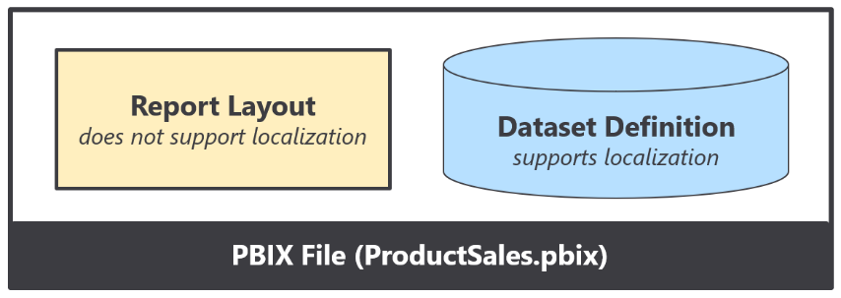

Think about a common scenario where you add a textbox or a button to a Power BI report and then you type in literal text for a string value displayed to the user. That text value is stored in the report layout and cannot be localized. Therefore, you must avoid using textboxes and buttons that include literal text when designing multi-language reports. As a second example, page tabs in a Power BI report are also problematic because their display names cannot be localized. Therefore, you must design multi-language reports so that page tabs are never displayed to the user.

A little later in this article you learn about the nitty-gritty details of building multi-language reports in Power BI Desktop. At this point, however, it's possible to make a high-level observation. For someone experienced with report building in Power BI Desktop, the challenge of learning how to build multi-language reports isn't as much about learning ***what to do*** but more about learning ***what not to do***. There are lots of popular Power BI report design techniques that cannot be localized and therefore cannot be used when building multi-language reports.

Before you dive into the details of building multi-language report, there are two important issues to consider. These issues are important because they could become serious show stoppers if you are attempting to follow the guidance in this article. The first issue is that multi-language reports must run in a dedicated capacity. That means you must be working with either Power BI Premium or the Power BI Embedded service in Microsoft Azure. Multi-language reports will not work correctly when loaded into a Power BI workspace in the shared capacity.

The second issue is that Power BI Apps don't support localization and can't be used to distribute multi-language reports. That means you will have to find an alternative approach to making multi-language reports accessible to users. This isn't a problem in a PaaS scenario when you're developing with Power BI embedding. In a SaaS scenario where licensed users are accessing reports using the Power BI service, you can use an alternative to Power BI Apps such as report sharing, direct workspace access or secure embed.

### Metadata Translations versus Content Translations

Metadata translations are used to localize the text for dataset object property values such as the names of tables, columns and measures. While metadata translation help to localize the names of tables and columns, they don't offer any assistance when it comes to localizing text values in the data itself. If your dataset has a **Products** table, how do you localize the text-based product names that exist in the individual rows of the **Products** table?

While adding metadata translations to your dataset is an essential first step, it doesn't always provide a complete solution by itself. A complete solution might require going further to localize the text-based content stored in table rows such as product names, product categories and country names. In certain reporting scenarios, the use of metadata translations must be complimented by a dataset schema designed to support **content translation**.

While every multi-language report will require metadata translations, it's is not as clear whether they will also require content translations. Some projects will require content translation while other projects will not. The final section of this article examines the important issues to consider when deciding whether to take on the extra work to implement content translation. This article waits until the end to discuss content translations because it is something that will not be required in every multi-language reporting project.

### The Multi-language Report Development Process

Now that you understand high-level concepts of building multi-language reports, it's time to move forward and discuss the multi-language report development process. The first step here is to decide how to package your dataset definitions and report layouts for distribution. Let's examine three popular approaches that are commonly used by Power BI customers.

In the first approach, the goal is to keep things simple by creating a single PBIX project file which contains both a dataset definition and a report layout. You can easily deploy this solution by importing the PBIX project file into a Power BI workspace. If you need to update the dataset definition or the report layout after they have been deployed, you can perform an upgrade operation by importing an updated version of the PBIX project file.



The single PBIX file approach doesn't always provide the flexibility you need. Imagine a scenario where one team is responsible for creating and updating dataset definitions while other teams are responsible for building reports. For a scenario like this, it makes sense to split out dataset definitions and report layouts into separate PBIX project files.

To use the shared dataset approach, you create one PBIX project file with a dataset definition and an empty report which remains unused. Once this dataset has been deployed to the Power BI Service, report builders can connect to it using Power BI Desktop to create report-only PBIX files. This makes it possible for the teams building reports to build PBIX project files with report layouts which can be deployed and updated independently of the underlying dataset.



While many customers use Power BI Desktop to create and maintain Power BI dataset definitions, it's not the only option. There is an alternative approach which makes it possible to take advantage of advanced data modeling features not available through Power BI Desktop. For example, you can use the Tabular Editor to create and maintain dataset definitions which can be saved in a JSON-file format with a .BIM extension as shown in the following diagram.

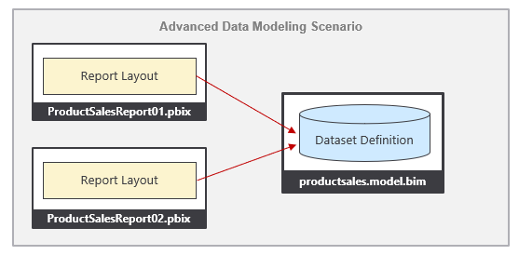

From the perspective of adding multi-language support to a Power BI solution, it really doesn't matter which of these three approaches you choose. The techniques and disciplines used to build multi-language reports remain the same whether you decide to build your solution using a single PBIX project file or with a combination of PBIX project files and a BIM dataset definition file. There are specific tasks you need to perform at the dataset level and other tasks you must perform when building report layouts in Power BI Desktop.

The multi-language report development process can be broken down into a few distinct phases. Each of these phases will be examined in detail in this article.

1. Add a localized label table to the dataset definition
2. Prepare the report layouts for localization
3. Add metadata translations to the dataset definition
4. Design and implement a content translation strategy (if required)

### The ProductSales.pbix Developer Sample

This article is accompanied by a developer sample based on a single PBIX file solution named **ProductSales.pbix**. This developer sample demonstrates building a multi-language report for Power BI which supports English, Spanish, French, German and Dutch. The PBIX project files for this developer solution and all the supporting resources used to build them are available to download or to view online from a GitHub repository at the following URL:

<https://github.com/PowerBiDevCamp/Multilanguage-Reports>

If you navigate to the home page for this GitHub repository, you will see several top-level folders.

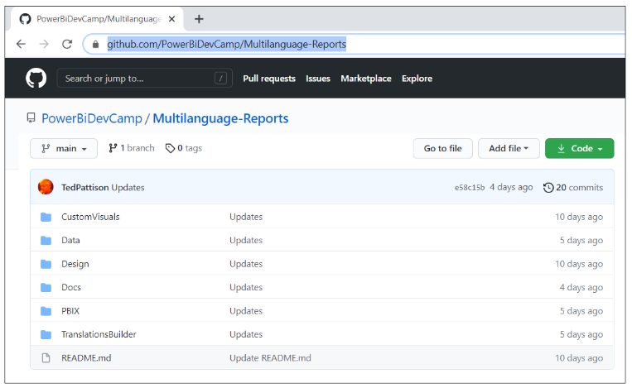

This GitHub repository provides a [PBIX folder](https://github.com/PowerBiDevCamp/Multilanguage-Reports/tree/main/PBIX) which contains several different versions of the **ProductSales.pbix** project file so you can see how the PBIX project looks at various stages of the multi-language report development process. This GitHub repository also contains a few other development projects including a Power BI custom visual named [**LocalizedLabel**](https://github.com/PowerBiDevCamp/Multilanguage-Reports/tree/main/CustomVisuals/localizedLabel) and a C# application named [**TranslationsBuilder**](https://github.com/PowerBiDevCamp/Multilanguage-Reports/tree/main/TranslationsBuilder) which demonstrates how to create an external tool which can be used alongside Power BI Desktop to automate the process of adding and updating metadata translations.

While this developer sample is based on a single PBIX project file approach, you should be able to use the same concepts and techniques to build multi-language reports in scenarios where your solution contains multiple PBIX files and optionally a dataset definition in a BIM file.

In addition to the project files and resources available in the GitHub repository, this developer sample also includes a live version which you can view to experience the completed multi-language report in action.

<https://multilanguagereportdemo.azurewebsites.net>

If you navigate to the live version of the report in a browser, you will see the completed solution for **ProductSales.pbix** displayed using it's default language of English. There are buttons in the left-hand navigation with captions such as **Home**, **Sales by Country** and **Sales by Product** which make it possible for the user to navigate from page to page. Experiment by clicking the buttons in the left-hand navigation to move form page to page.

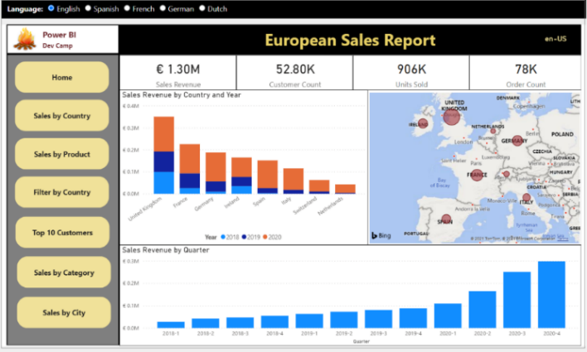

At the top of the web page above the embedded report, you will see a set of radio buttons that allow you to reload the report using a different language including Spanish, French, German and Dutch.

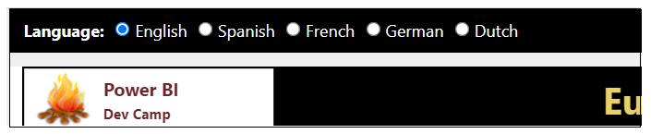

Experiment by clicking these radio buttons to load the report in different langauges. For example, click on the radio button with the caption of **German**. When you do, there is JavaScript behind this page that responds by reloading the report using the language of German intead of English. You can see that all the button captions in the left-hand navigation and text-based values in the visuals on the page now display their German translations instead of English.

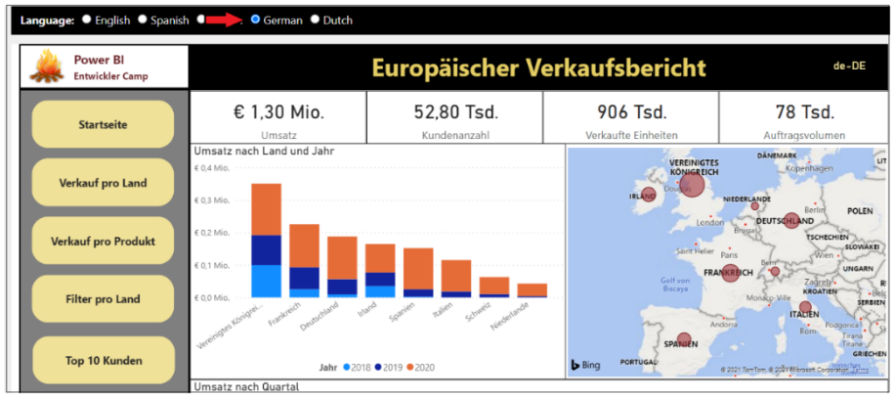

When creating a report for Power BI, it's a common practice to add text-based labels for report elements such as titles, headings and button captions. However, this creates an unexpected bump in the road when building multi-language reports in Power BI Desktop. The problem is that you cannot create labels for a report using the standard approach where you add textboxes and buttons to the report. That's because any text you add for a property value of a textbox or a button is stored in the report layout and, therefore, cannot be localized.

As discussed earlier in this article, the Power BI localization features are supported at the dataset definition level but not at the report layout level. At first you might ask the question ***how can I localize text-based values that are not stored inside the dataset definition?*** The answer to this question is that you cannot.

A better question to ask is ***how can I add the text-based values for labels so they become part of the dataset definition?*** Once the text-based values for labels become part of the dataset definition, then they can be localized. This leads to an innovative approach of creating the **Localized Labels** table. This design technique will be discussed in detail in the next section of this article.

The **ProductSales.pbix** developer sample demonstrates how to implement localized labels in the left navigation menu. The following screenshot shows the how button captions are translated when loaded with five different languages including English, Spanish, French, German and Dutch.

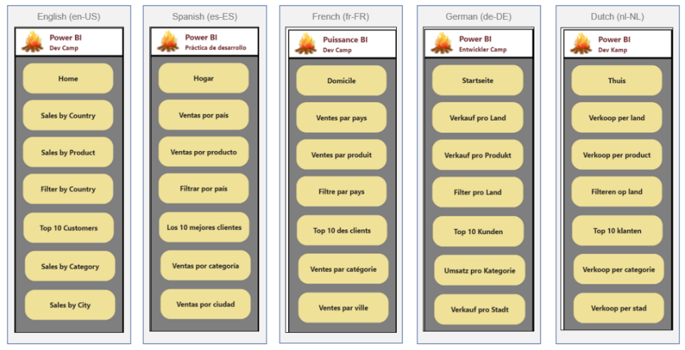

The **ProductSales.pbix** developer sample also demonstrates how to implement content translation. With metadata translations, you can see the names of columns and measures change as you switch between languages. Content translation go further to localize the product names in rows of the **Products** table change. The following screenshot shows how the **ProductSales.pbix** developer sample provides content translations for product names as well.

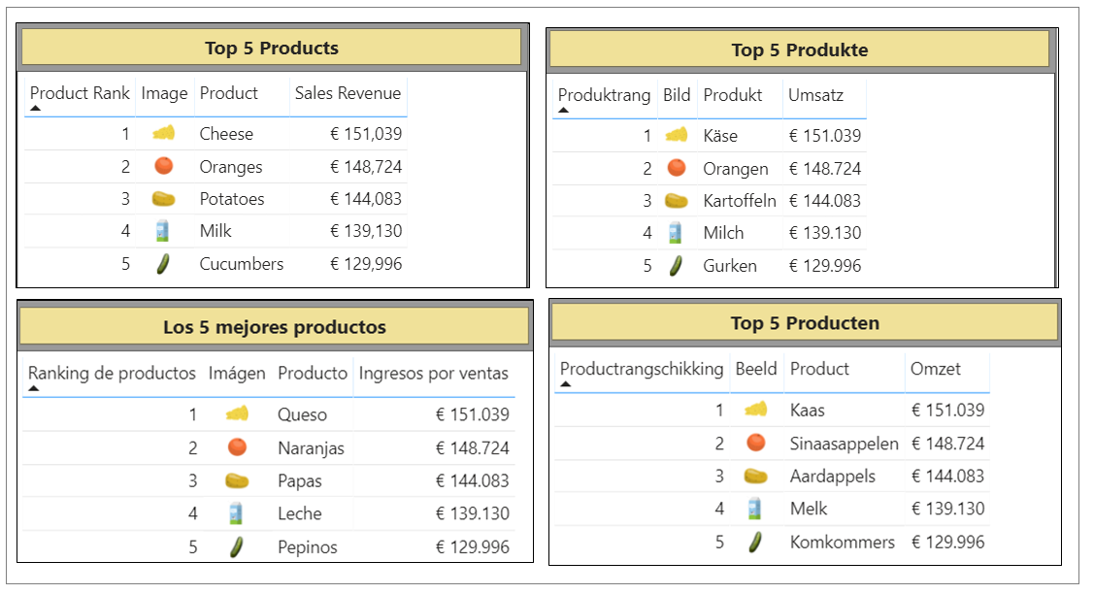

## Prepare Datasets and Reports for Localization

So far you've learned about essential concepts and background information you'll need to build multi-language reports. Now, it's time to move ahead and discuss the actual development process. We'll start by discussing a few general topics associated with software localization. After that, we'll move on to topics that are specific to Power BI and designing reports in Power BI Desktop.

When it comes to localizing software, there are some universal principals to keep in mind. The first is to plan for localization from the start of any project. It's significantly harder to add localization support to an existing dataset or report that was initially built without any regard for Internationalization or localization. This is especially true with Power BI reports because there are so many popular design techniques that do not support localization. You might find that much of the work for adding localization support to existing Power BI reports involves moving backward and undoing the things that do not support localization before you can move forward with design techniques that do support localization.

Another important concept in localization is to plan for growth. A label that's 400 pixels wide when displayed in English could require a much greater width when translated into another language. If you optimize the width of your labels for text in English, you might find that translations in other languages introduce unexpected line breaks or get cut off which, in turn, creates a compromised user experience.

Adding a healthy degree of padding to localized labels is the norm when developing Internationalized software and it's essential that you test your reports with each language you plan to support. In essence, you need to ensure your report layouts looks the way you expect with any language you have chosen to support.

### Avoid Report Design Techniques that Do Not Support Localization

If you have experience with Power BI Desktop, it's critical that you learn which report design techniques to avoid when you begin building multi-language reports. Let's begin with the obvious things which cause problems due to a lack of localization support.

* Using textboxes or buttons with literal text
* Adding literal text for the title of a visual
* Displaying page tabs to the user

The key point here is that any literal text that gets added to the report layout cannot be localized. Consider the case where you add a column chart to your report. By default, a Cartesian visual such as a column chart is assigned a dynamic value to its **Title** property which is parsed together using the names of the columns and measures that have been added into the data roles such of **Axis**, **Legend** and **Values**.

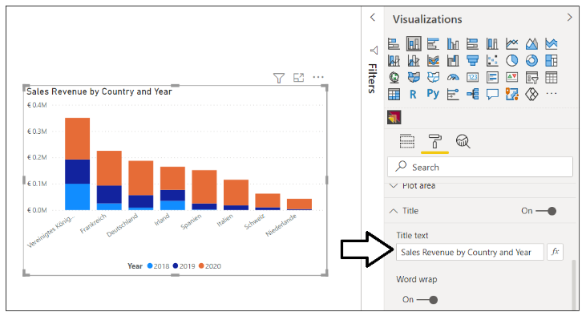

There is good news here. The default **Title** property for a Cartesian visual is dynamically parsed together in a fashion that supports localization. As long as you supply metadata translations for the names of columns and measures in the underlying dataset definition (e.g. **Sales Revenue**, **Country** and **Year**), the **Title** property of the visual will use the translations for whatever language has been used to load the report. The following table shows how the default **Title** property of this visual is updated for each language supported by the **ProductSales.pbix** developer sample.

|  |  |
| --- | --- |
| Language | Visual Title |
| English (en-US) | Sales Revenue by Country and Year |
| Spanish (es-ES) | Ingresos por ventas por país y año |
| French (fr-FR) | Chiffre d’affaires par pays et année |
| German (de-DE) | Umsatz nach Land und Jahr |
| Dutch (nl-NL) | Omzet per land en jaar |

Even if you don’t like the dynamically-generated visual **Title**, you must resist the temptation to replace it with a literal text value. Any literal text you type into the **Title** property of the visual will be added to the report layout and cannot be localized. Therefore, you should either leave the visual **Title** property with its default value or hide the title so it is not displayed.

### Create the Localized Labels Table

When designing reports, it's a common practice to use text-based labels for report elements such as titles, headings and button captions. You've learned that any text value stored in a report layout cannot be localized. If you want to localize the text-based labels which are displayed on a Power BI report, then those labels must be defined inside the dataset. This leads to the innovative technique of creating a specialized table in the dataset definition for localized labels.

The idea behind the **Localized Labels** table is pretty simple. You can localize the name of any measure inside a dataset. When you need a text label for a report title, you can add a new measure to the **Localized Labels** table and then give the measure a name for the English label such as **European Sales Report**. Since the label is a measure name, you can add metadata translations to supply a localized version of this label for each language.

There are several different techniques that can be used in Power BI Desktop to create a new table for localized labels. One quick way to accomplish this is to click on the **New table** button on the **Table tools** tab and then add a DAX expressions with the **DATATABLE** function to create a new table named **Localized Labels**.

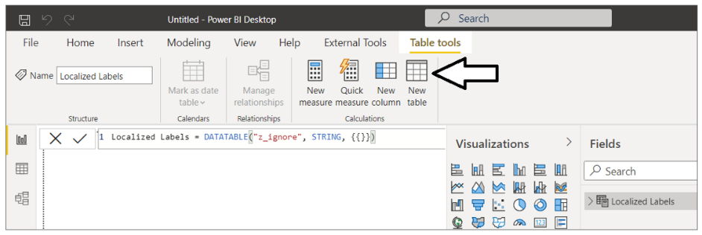

Below is the full DAX expressions that creates the **Localized Label** table. The **DATATABLE** function requires that you create a least one column. Therefore the table is created with a single column named **z_ignore** which can be hidden from report view.

Localized Labels = DATATABLE("z_ignore", STRING, {{}})

Once you have created the **Localized Labels** table, you can begin to add new measure just as you would in any other Power BI Desktop project.

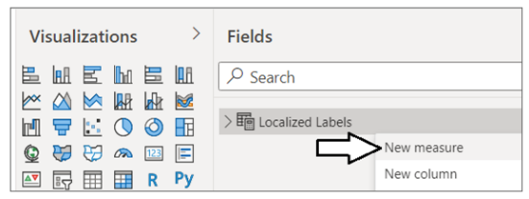

When creating a measure for a localized label, you can add the label text as the measure name and then set the DAX expression for this measure to a static value of **0**. This value of **0** has no significance and is only added because each measure must be created with a DAX expression.

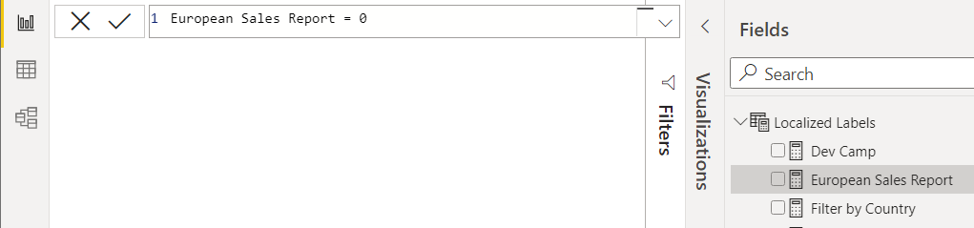

The **ProductSales.pbix** developer sample demonstrates creating a **Localized Labels** table to provide a set of localized labels for all titles, headings and button captions used throughout the report.

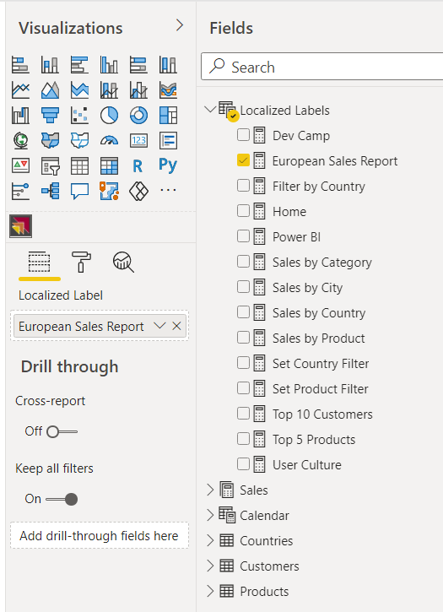

Now that you've seen how to create the **Localized Labels** table, it's time to move ahead and learn how to surface the measure name for a localized label on a Power BI report.

### Display Localized Labels using Power BI Core Visuals

The technique used to display measure names from the **Localized Labels** table in a Power BI report is neither straightforward nor intuitive. You can start by adding a Cartesian visual such as the Stacked Barchart visual to a page and then adding the measure for the desired localized label into the **Values** data role. After that, you can adjust the visual's width and height so only the visual **Title** property can be seen by the user.

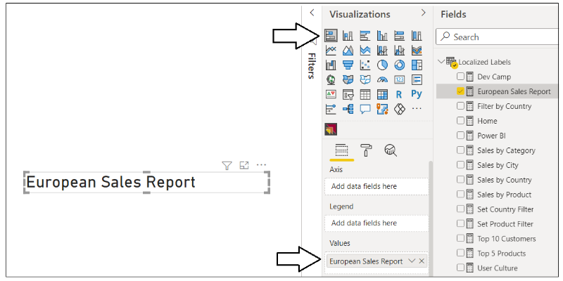

After you have added the visual to a report page to display a localized label, you can adjust the font formatting for the label in the **Title** section of the **Format** pane as shown in the following screenshot.

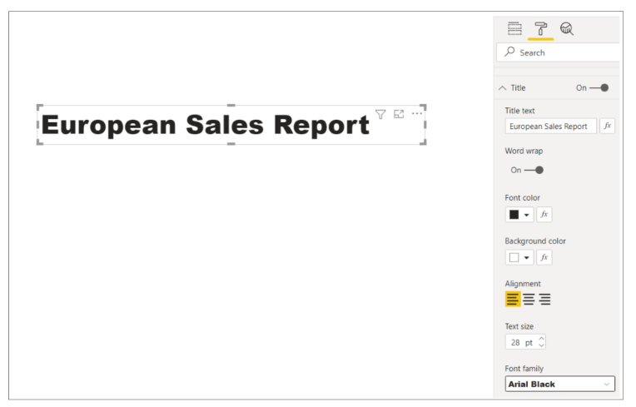

In summary, you can use one of the Power BI core visuals such as the Stacked Barchart to display localized labels for titles, headings and button captions. However, most report authors find that the design experience is pretty limited when formatting a localized label using any of the Power BI core visuals. For example, you cannot configure padding for the label or center its text vertically. In the next section, we will discuss creating a custom visual to provide a better design experience for formatting the display of localized labels on a Power BI report.

### Display Localized Labels using a Custom Visual

The previous section discussed using a Stacked Barchart visual to display a localized label. While this technique can be used reliably to create multi-language reports, it is clear that none of the Power BI core visuals were designed to support this scenario. The reason this technique works is really a more of a coincidence than a planned outcome. Furthermore, there is extra overhead due to the visual implementation being designed to do far more then just display a title. These issues combine together to provide a motivation to create a custom visual project that is explicitly designed to support the scenario of displaying localized labels in a multi-language report.

This GitHub repository mentioned earlier contains a [CustomVisuals](https://github.com/PowerBiDevCamp/Multilanguage-Reports/tree/main/CustomVisuals/localizedLabel) folder. Inside the **CustomVisuals** folder, there is a child folder with a custom visual project named [**localizedLabel**](https://github.com/PowerBiDevCamp/Multilanguage-Reports/tree/main/CustomVisuals/localizedLabel). If you have experience with custom visual development, you can open the [localizedLabel project source code](https://github.com/PowerBiDevCamp/Multilanguage-Reports/blob/main/CustomVisuals/localizedLabel/src/visual.ts#L33) in Visual Studio Code to see how this custom visual is implemented. The **CustomVisuals** folder also contains a custom visual distribution file for the **localizedLabel** project named [localizedLabe.1.0.0.pbiviz](https://github.com/PowerBiDevCamp/Multilanguage-Reports/raw/main/CustomVisuals/localizedLabel.1.0.0.pbiviz). You can import this custom visual distribution file directly into a Power BI Desktop project to begin using this custom visual to display localized labels.

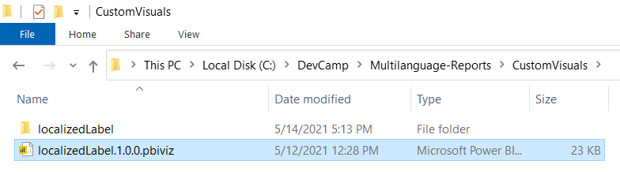

Once you have imported the custom visual distribution file named [localizedLabe.1.0.0.pbiviz](https://github.com/PowerBiDevCamp/Multilanguage-Reports/raw/main/CustomVisuals/localizedLabel.1.0.0.pbiviz) into a Power BI Desktop project, you should be able to begin using it. After you have added an instance of the **Localized Label** visual to a report, you can then populate the **Localized Label** data role using one of the measures in the **Localized Labels** table as shown in the following screenshot.

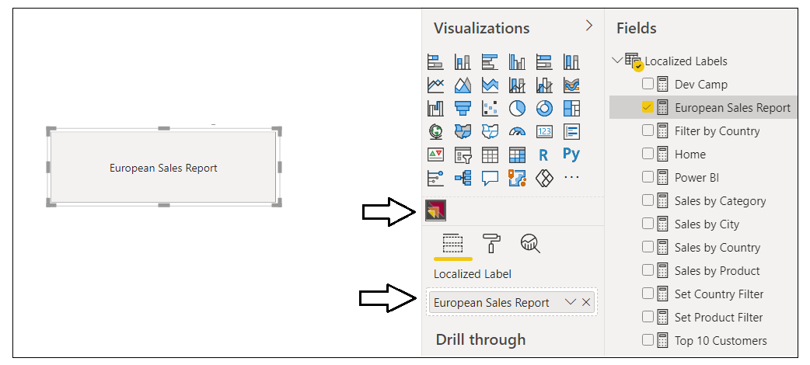

After you have configured the **Localized Label** data role with a measure from the **Localized Labels** table, you can then configure the font and background formatting of the visual in the **Label Properties** section of the Format Pane.

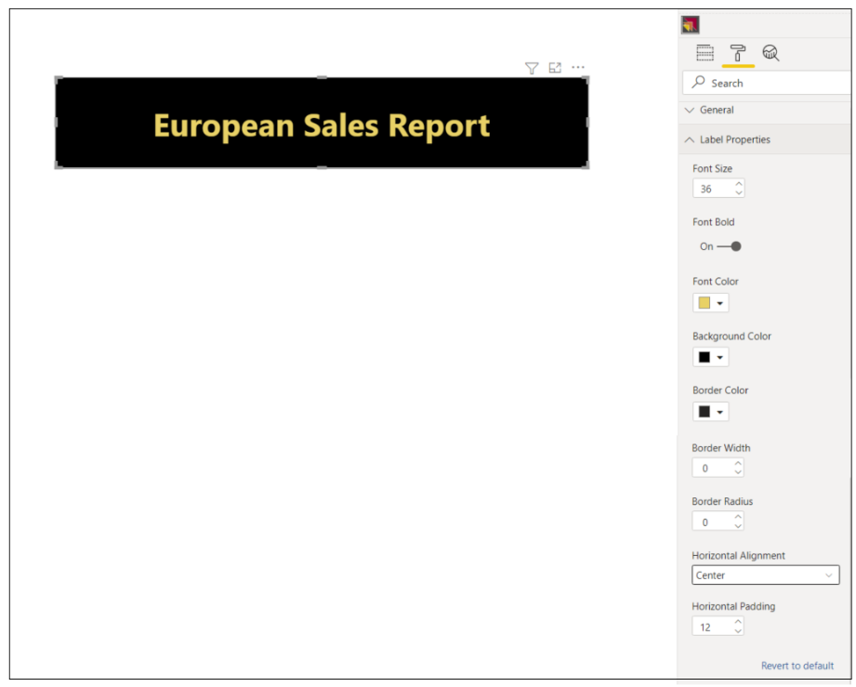

### Add Support for Page Navigation

As you recall, you cannot display Power BI report page tabs to the user in a multi-language report because page tabs do not support localization. Therefore, you must provide some other means for users to navigate from page to page. This can be accomplished using a design technique where you add shapes to a report which act as buttons. When the user clicks on a shape, the shape will apply a bookmark to navigate to another page. Let's step through the process of building a navigation menu that supports localization using measures from the **Localized Labels** table.

The first thing you need to do is to hide every page in the report except for the first page which acts as the landing page.



Next, create a set of bookmarks. Each bookmark should be created to navigate to a specific page. The **ProductSales.pbix** developer sample demonstrates this technique by adding a bookmark for each page supported by the navigation menu.

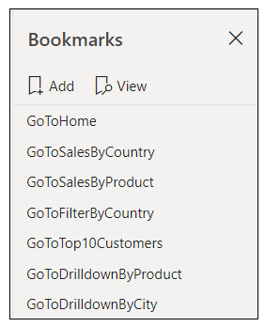

Remember, that you cannot add a button with literal text to a multi-language report. Instead, you must be a bit more creative and use a technique that supports localizing button captions. This can be accomplished by using a shape which is overlaid on top of a localized label visual. The shape should be configured as completely transparent without a border or any background color. The shape should also be configured with an action to trigger one of the bookmarks.

From a design perspective, the user sees the localized label with the button caption but does not see the shape. When the user clicks on the localized label visual, the invisible shape on top acts as a button and responds to the click event by applying a bookmark to navigate to the target page.

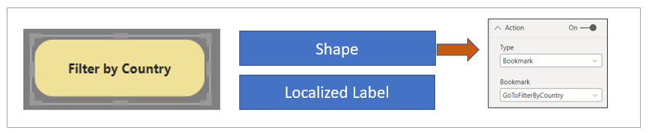

At this point, you've learned how to create the **Localized Labels** table in a dataset and you've learned how to prepare a Power BI report for localization. These are the localization techniques you will continue to use as you create and maintain reports that must support multiple languages. Now it's time to move on and examine the topic of extending a Power BI dataset with metadata translations. Once you learn to do this, you can then add support for whatever languages you need in your multi-language reporting solutions.

## Add Metadata Translations to a Dataset Definition

The previous section discussed how to prepare Power BI datasets and reports for localization. In this section we'll discuss how to extend a dataset definition by adding metadata translations. This is a task you can accomplish by hand using an external tool named **Tabular Editor**. Alternatively, you can write custom code to automate the process of adding metadata translations to Power BI datasets using the **Tabular Object Model (TOM)**. With either approach you can work directly on a PBIX project file that is open in Power BI Desktop. You also have the flexibility to work with datasets defined in BIM files or live datasets running in Azure Analysis Services (AAS) or the Power BI Service.

While Power BI Desktop doesn't offer direct support for adding and managing metadata translations, it is still often used in the multi-language report development process. Once you've opened a PBIX project file in Power BI Desktop, the dataset defined inside is loaded into memory and becomes accessible to both the Tabular Editor and to custom code you write using the TOM.

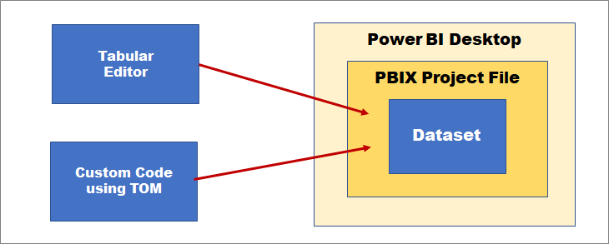

While the Tabular Editor and custom code you write using TOM can update a dataset loaded into memory in a session of Power BI Desktop, they do not have the ability to actually save their changes to the underlying PBIX file. After you have updated a dataset using Tabular Editor or custom code in an external tool, you will need to return to Power BI Desktop and invoke the **Save** command so your changes are actually persisted into the underlying PBIX project file. If you close the PBIX project file session in Power BI Desktop without saving, all your changes will be discarded.

This preceding diagram shows how you can add metadata translations to a dataset loaded into Power BI Desktop. This works well in a scenario where you're building a PBIX project file and preparing to distribute it for the first time. However, You should also understand that it's also possible to access a Power BI dataset directly in the Power BI Service. That means you can connect to a production dataset and manage its metadata translations using the exact same techniques as shown in the following diagram.

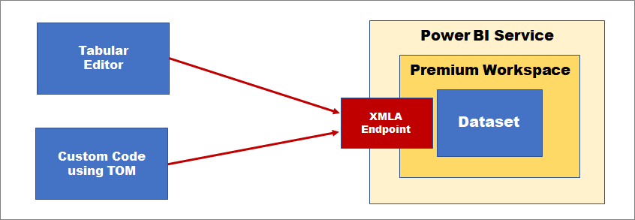

Access to a Power BI dataset running in the Power BI Service is routed through the XMLA endpoint which requires that the hosting workspace is in a dedicated capacity. In other words, you must ensure your workspace has a diamond when viewed in the Power BI Service. This requirement can be met with either Power BI Premium, Power BI Premium Per User or one of the A SKUs for the Power BI Embedded Service in Microsoft Azure.

### Install the Tabular Editor

If you plan to work with metadata translations, you should become familiar working with the Tabular Editor. Even if you eventually plan to write your own TOM code to manage translations, working with the Tabular Editor is a great way to get started as you begin to learn how translations are stored within the metadata for a Power BI dataset definition. You can download the open source version of Tabular Editor (version 2) for free from the web page at following URL:

<https://github.com/otykier/TabularEditor>

The Tabular Editor provides first-class support for managing dataset translations. However, this is just one of the many areas in which this tool shines. In addition to its metadata translations support, Tabular Editor provides a comprehensive toolset for advanced data modeling that go far beyond the data modeling support available in Power BI Desktop. Tabular Editor is currently recognized by industry experts as the premiere tool for building and optimizing large-scale Power BI datasets.

The Tabular Editor was created and continues to be maintained by a very talented developer in the Power BI community named Daniel Otykier. While the open source version of Tabular Editor is available for free, Daniel has recently introduced Tabular Editor version 3 which is based on a paid licensing model. While the free version of Tabular Editor provides all the support you need to add and manage metadata translations, you must purchase Tabular Editor version 3 to take advantage of the newer advanced data modeling and dataset management features that are not available in the free version. You can get more information from the Tabular Editor website at <https://tabulareditor.com>.

After you've installed Tabular Editor, Power BI Desktop displays a tile to launch it on the **External Tools** tab in the ribbon. Clicking on the **Tabular Editor** tile in Power BI Desktop will launch Tabular Editor and automatically open the dataset definition for the current PBIX project file.

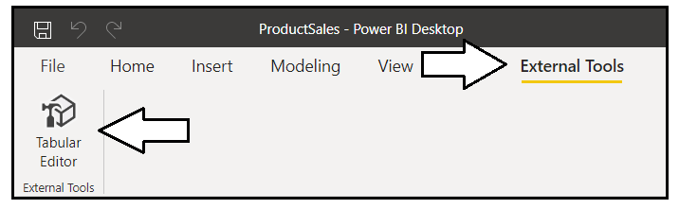

### Add Metadata Translations by Hand using Tabular Editor

The Tabular Editor provides an advanced user experience for viewing and modifying dataset objects such as tables, columns and measures. If you expand the **Tables** node in the left navigation, you can select a dataset object and then view its properties in a property sheet on the right. The following screenshot demonstrates selecting a calculated table named **Calendar** in the **ProductSales.pbix** developer sample. Once you've selected a dataset object, you can view or modify any of its properties including the DAX expression used to create the calculated table.

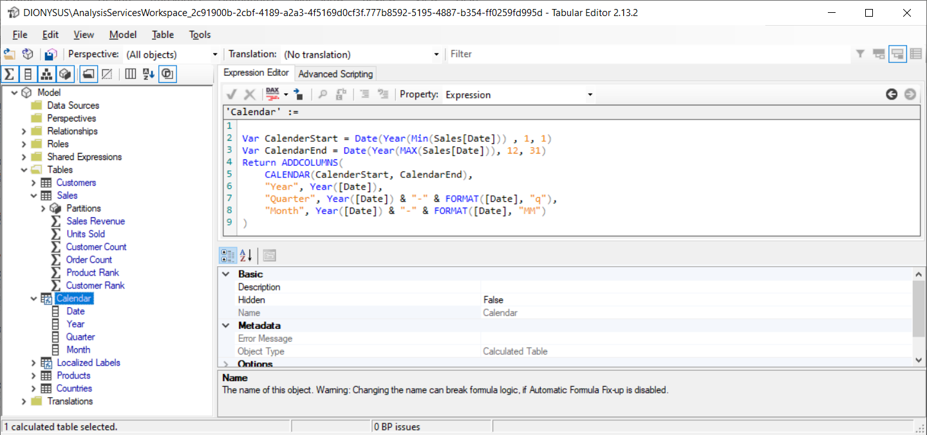

Underneath the **Tables** node in the Tabular Editor, there is another top-level node named **Translations**. This node contains all the **Culture** objects which have been added to the current dataset definition. By default, every new dataset definition contains a single **Culture** object based on a default language and a default locale. The **ProductSales.pbix** developer sample has default **Culture** object based on **English (en)** as its language and the **United States (US)** as its locale. That's why this default culture is tagged with an identifier of **en-US**.

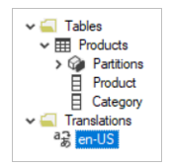

If you examine the property sheet in the Tabular Editor for a dataset object, you will see there is a **Translated Names** section which tracks the value of the **Caption** property. By default, all the translations for the default **Culture** object will have blank values. If you want to add translations manually, you can copy the **Name** property for a dataset object and then paste that text value into the default Culture in the **Translated Names** section.

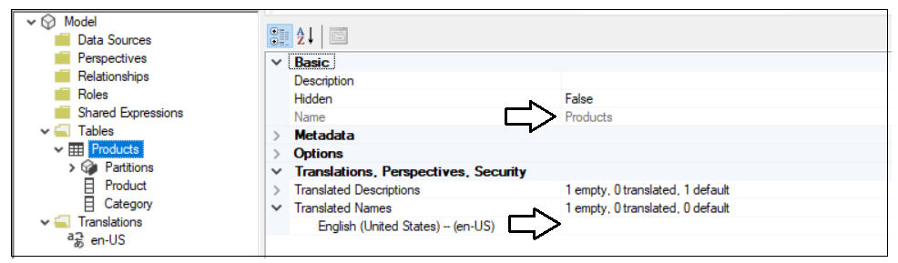

To add support for secondary languages, you must add one or more new **Culture** objects to the dataset definition. This task can be accomplished by right-clicking the **Translations** node and selecting the **New Translation** menu command.

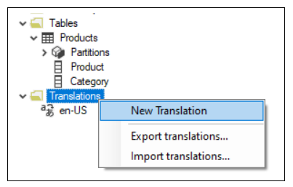

When you invoke the **New Translation** command, you'll be prompted with the **Select Culture** dialog which makes it possible to find and add a new **Culture** object for a specific language and locale.

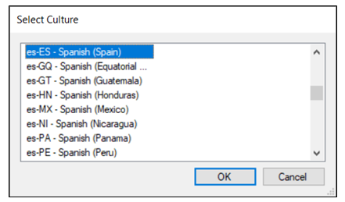

The dataset for **ProductSales.pbix** has been extended with four **Culture** objects to add metadata translation support for four secondary languages including Spanish (es-ES), French (fr-FR), German (de-DE) and Dutch (nl-NL).

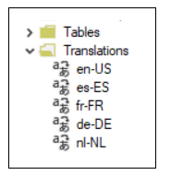

Once you have added a **Culture** object for each language you need to support, the **Translated Names** section of the property sheet for each dataset object will provide the ability to add a new translation for each language. The following screenshot shows how the metadata translations have been added to supply translated names for the **Products** table.

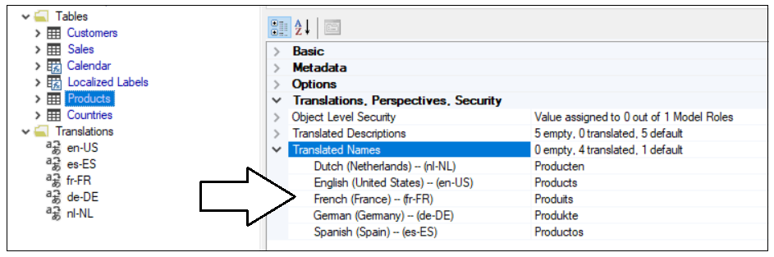

The **ProductSales.pbix** developer sample also contains translations for all the measures in the **Localized Labels** table.

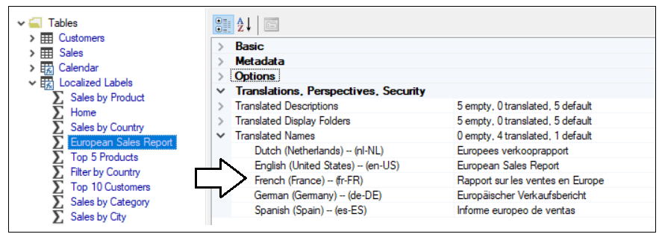

### Save a Dataset Definition as a BIM File

The Tabular Editor provides a **Save As** command which can be used to save the current dataset definition in a JSON file format. By convention, a JSON file with a tabular dataset definition is created with a **\*.BIM** extension. You can build up your understanding of how translations work by saving a dataset definition as a **BIM** file and then inspecting the JSON inside. Let's begin by examining the JSON for a simple a dataset definition which contains a table with two columns.

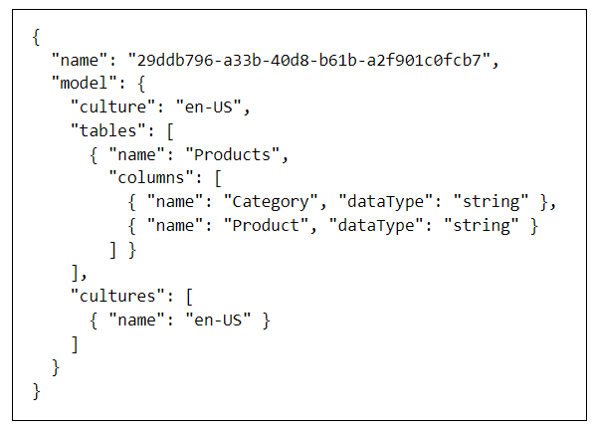

As you can see from the previous screenshot, this new PBIX project file has been created with a default Culture of **en-US**. However, the default Culture object is created without any translations inside. You must populate the default Culture object with translations yourself either by hand or by writing code to automate the process. Once you have populated the default Culture object with translations, you can see these translations are tracked on an object-by-object basis in the **tables** collection using the **translatedCaption** property.

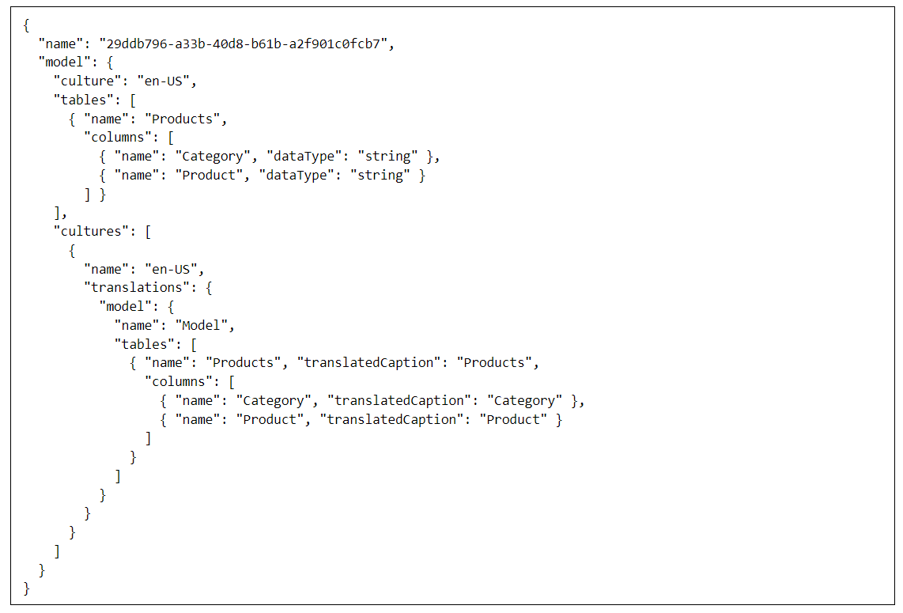

As you begin to add translations for other languages, they're tracked in a similar fashion in a separate **Culture** object.

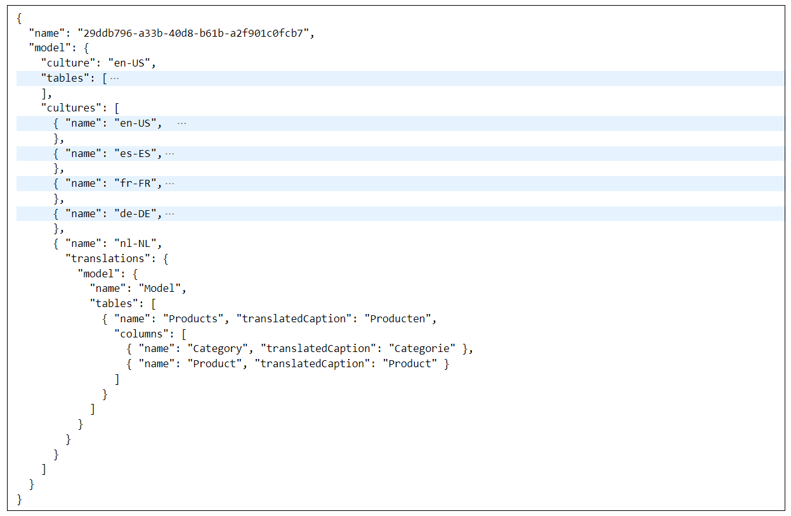

Think about what happens when you add metadata translations by hand in Tabular Editor. Behind the scenes, Tabular Editor adds metadata translations by populating **Culture** objects in the dataset definition.

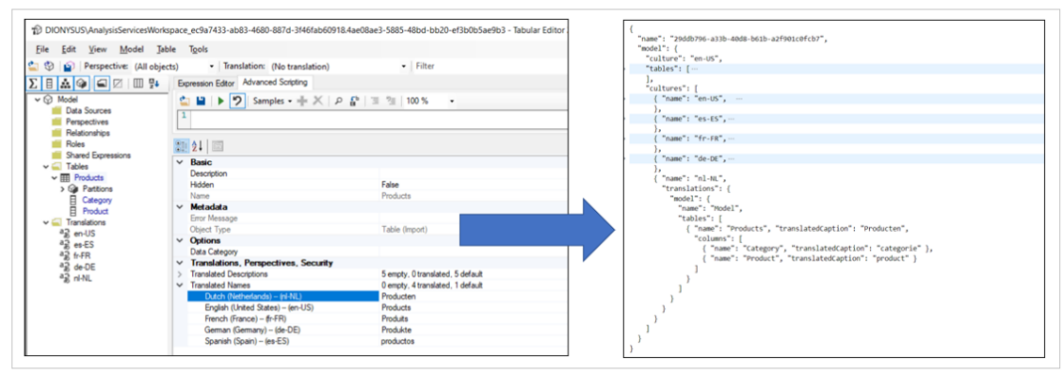

Tabular Editor supports exporting and importing translations using a JSON file format. This can be a useful feature when you need to integrate human translators into the multi-language report development process. Imagine a scenario where you have just finished creating a dataset in Power BI Desktop by adding the tables, columns and measures. Next, you can open the dataset definition in Tabular Editor and populate the metadata translations for default Culture. After that, you can export the translations in a JSON file formatting using the **Export Translations…** menu command.

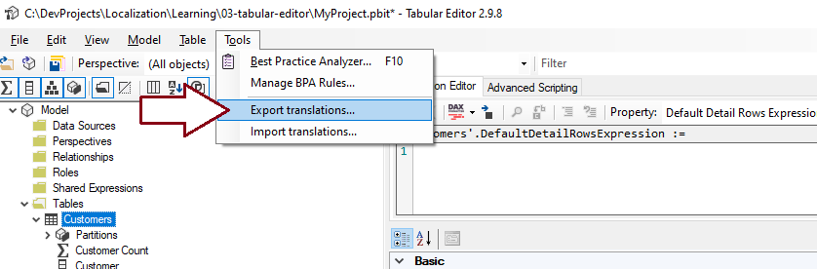

The exported JSON file with the metadata translations has the exact same JSON layout as the **Culture** object in a **BIM** dataset definition file. The difference is that the JSON file with exported translations omits any metadata from the dataset definition that does not involve metadata translations. The exported JSON file can then be extended with other **Culture** objects containing the translations for secondary languages. Once the JSON file has been extended with **Culture** objects for each language, the updated file with the translations can then be imported back into Tabular Editor to eliminate the need to add metadata translations by hand.

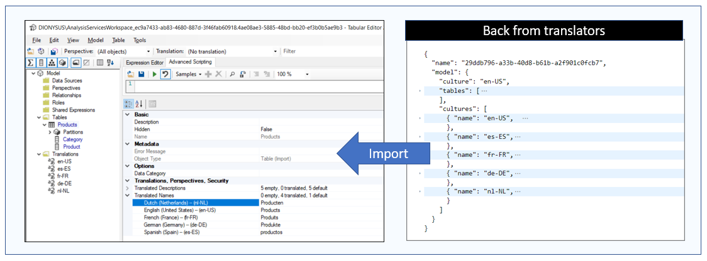

So far, you've learned the Tabular Editor provides a simple way to add and manage metadata translations by hand. While adding translations by hand with the Tabular Editor is a great way to learn about translations, it can become more tedious as the number of database objects requiring translations increases.

If the number of tables and fields in a dataset is small, you can add translations by hand without any problems. But what happens when you're working with a large dataset where the dataset contains 30 tables, 500 columns and 250 measures? It can take you 3-4 hours of tedious copy-and-paste operations just to populate the translations for the default Culture object in Tabular Editor. The need to add and managed metadata translations in a more scalable manner provides motivation for learning how to write custom code to automate the process using Tabular Object Model (TOM).

### Program with Advanced Scripting in Tabular Editor

Behind the scenes, the Tabular Editor uses the Tabular Object Model (TOM) to create and manage dataset objects and to read and update dataset object properties. The Tabular Editor also provides an Advanced Scripting feature which makes it possible to write and run batches of C# code which program against TOM. The purpose of this section is to get you started with a few quick samples which demonstrate automating the process of creating and managing translations.

The first thing to understand about the Advanced Scripting features is that you're not really programming directly against TOM. Instead, Tabular Editor provides a set of TOM wrapper objects. You program against the TOM wrapper objects and these wrapper objects, in turn, make calls into TOM on your behalf. If you plan to become productive with Advanced Scripting, you should start off by reading the [Advanced Scripting documentation](https://docs.tabulareditor.com/Advanced-Scripting.html).

The Tabular Editor provides a programming model with a few essential top-level objects. First, there is a **Model** object that provides access to all the objects within the current dataset definition. The **Model** object makes it possible to enumerate through every table in order to examine or modify the columns and measures inside. There is also a **Selected** object which makes it possible to execute code against any object or objects that are selected in the treeview control of the left navigation menu. Finally, there is an **Output** object that makes it possible to display a debugging message in a model dialog.

The Advanced Editor is great because it provides instant gratification. Start by typing in a simple batch of C# code.

String message = "Hello Advanced Scripting";

Output(message);

Click the green arrow button on the Advanced Editor toolbar or press the **{F5}** key to execute your code. When the code executes, it should display a model dialog with your message.

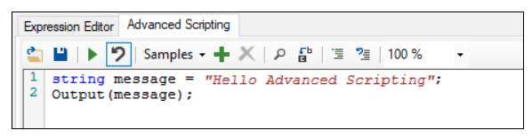

Congratulations. You can now tell all your friends that you use Advanced Scripting in Tabular Editor!

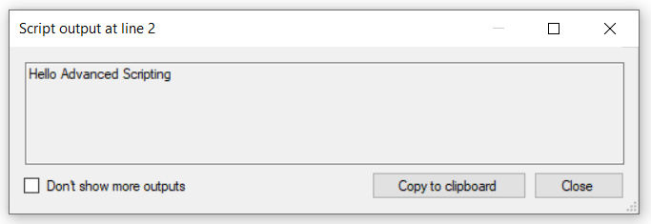

The **Selected** object makes it possible to write generic batches of C# code that program against whatever dataset object is selected in the treeview control of the left-hand navigation menu. For example, you can experiment by writing the following C# code which displays the name of the **Selected** dataset object.

var SelectedObject = Selected;

Output(SelectedObject.Name);

Now select a table in the treeview and execute the C# code. Your code is able to access the dataset object for whatever table, column or measure is selected in the treeview control and to retrieve the value of the **Name** property.

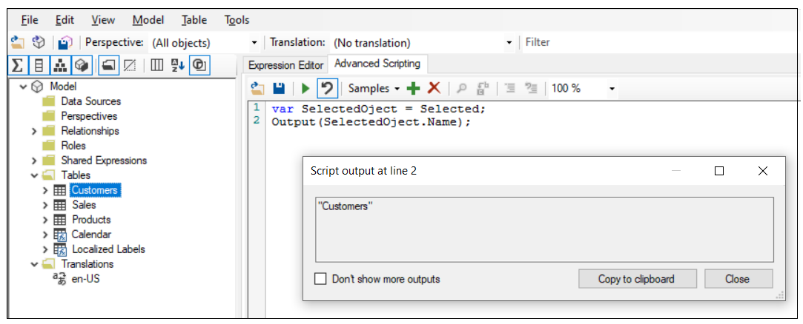

Now let's write some C# code to populate a dataset object with the metadata translations for the default culture. The first thing you need to determine in this scenario is the default culture name for the current dataset definition. Culture names are stored as a string value which specifies a language and a locale. For example, a culture name of **en-US** specifies the culture language is English and the culture locale is the United States. Your code can dynamically determine the default culture name by examining the **Culture** property of the top-level **Model** object.

When using Advanced Scripting, the TOM wrapper classes for dataset objects provide two important convenience collections named **TranslatedNames** and **TranslatedDescriptions**. These convenience collections are implemented as dictionaries which make it easy to add or overwrite a translation for a dataset object using the culture name as a key.

Selected.Table.TranslatedNames["en-US"] = "Customers";

Now, let's say you want to write C# code which programs against a **Table** object selected in the left-hand treeview and add translations for the default culture. First, you can determine the default culture using **Model.Culture**. Next, you can copy the **Name** property and **Description** property of the **Selected.Table** object and add them to the **TranslatedNames** collection and the **TranslatedDescriptions** collection.

Selected.Table.TranslatedNames[Model.Culture] = Selected.Table.Name;

Selected.Table.TranslatedDescriptions[Model.Culture] = Selected.Table.Description;

This code demonstrates a pattern for programming dataset objects that populates the default culture with translations. You can observe how values for the **Name** property and the **Description** property can be used to add metadata translations into the default culture using the convenience collections **TranslatedNames** and **TranslatedDescriptions**.

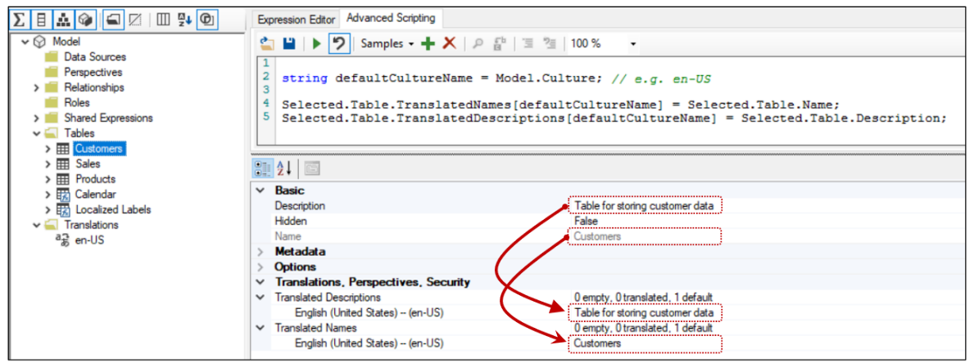

When using Advanced Scripting, all dataset objects provide the two convenience collections named **TranslatedNames** and **TranslatedDescriptions**. When you program against columns, measures and hierarchies, you have access to a third convenience collection named **TranslatedDisplayFolders** as shown in the following code listing.

Selected.Measure.TranslatedNames[Model.Culture] = Selected.Measure.Name;

Selected.Measure.TranslatedDescriptions[Model.Culture] = Selected.Measure.Description;

Selected.Measure.TranslatedDisplayFolders[Model.Culture] = Selected.Measure.DisplayFolder;

Once again, this code follows the pattern shown earlier where translations for the default culture are created from dataset object properties which in this scenario are **Name**, **Description** and **DisplayFolder**. While you could copy and paste these property values by hand in the Tabular Editor, automating these tasks with code is a much better approach.

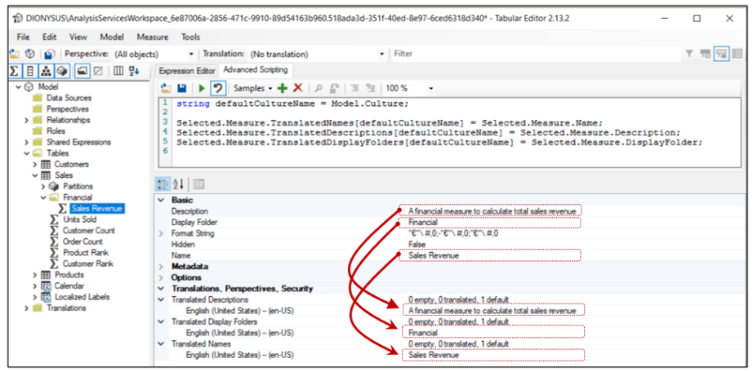

Now let's take this example one step further so you don't have to execute the code on each dataset object individually. You can write an outer **foreach** loop that enumerates through the **Tables** collection of the **Model** object. Inside the outer **foreach** loop, you can add inner **foreach** loops to enumerate through the columns, measures and hierarchies for each table. You can typically avoid hidden tables as their columns and measures will not require localization.

foreach(Table table in Model.Tables) {

if(!table.IsHidden){

// generate translation for table name

table.TranslatedNames[Model.Culture] = table.Name;

foreach (Column column in table.Columns) {

// generate translation for column name

column.TranslatedNames[Model.Culture] = column.Name;

};

foreach (Measure measure in table.Measures) {

// generate translation for measure name

measure.TranslatedNames[Model.Culture] = measure.Name;

};

foreach (Hierarchy hierarchy in table.Hierarchies) {

// generate translation for hierarchy name

hierarchy.TranslatedNames[Model.Culture] = hierarchy.Name;

};

}

}

Now, it’s time to move beyond the Tabular Editor and examine writing a C# application which can be integrated with Power BI Desktop as an External Tool. This approach will provide greater flexibility then using the Advanced Scripting features in Tabular Editor mainly due to the fact that the code in the next section will program against TOM directly.

If you'd like to use the Advanced Scripting features to automate tasks associated with localization, your next step is to learn how to save your C# code as [custom actions](https://docs.tabulareditor.com/Custom-Actions.html). This will make it possible for you to create a library of reusable code snippets that can be shared across a team and used in the multi-language report development process.

## Create an External Tool for Adding Metadata Translations

In the previous section we examined using the Advanced Scripting features of Tabular Editor to automate tasks involved with localization and the multi-language report development process. In this section we'll examine a different approach for writing custom code to add and manage metadata translations that will provide greater flexibility. This approach will involve writing a .NET application using C# that can be integrated with Power BI Desktop as an external tool.

When developing a .NET application with C#, you can add a reference to the [Analysis Management Object (AMO) library](https://docs.microsoft.com/en-us/analysis-services/amo/developing-with-analysis-management-objects-amo?view=asallproducts-allversions) which makes it possible to program against the Tabular Object Model (TOM). TOM allows your code to establish a direct connection to the model for a dataset loaded into Power BI Desktop. This provides the most direct approach for writing custom code to automate the process of managing metadata translations within a Power BI dataset.

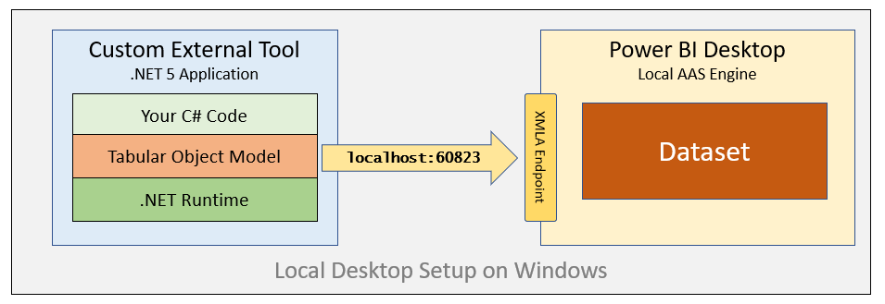

This article assume that the reader already has experience programming with TOM. If you are not already familiar with TOM, you should consider reading through [Programming Datasets with the Tabular Object Model (TOM)](https://www.powerbidevcamp.net/articles/programming-datasets-with-TOM/) to learn more about the fundamentals of TOM before continuing with the material in the following section. This article will focus on the aspects of writing code with TOM that is specific to working with metadata translations.

### The TranslationsBuilder External Tool Developer Sample

The [GitHub repository](https://github.com/PowerBiDevCamp/Multilanguage-Reports/tree/main/PBIX) for the **ProductSales** developer sample includes a .NET application named [TranslationsBuilder](https://github.com/PowerBiDevCamp/Multilanguage-Reports/tree/main/TranslationsBuilder) which demonstrates how to develop an external tool for Power BI Desktop. As you will see, deploying a custom .NET application as an external tool for Power BI Desktop provides a simple and effective strategy to automate localization tasks in the multi-language report development process.

The **TranslationsBuilder** developer sample is a .NET application built using C# which programs against TOM to automate adding secondary cultures and metadata translations to a Power BI dataset. The **TranslationsBuilder** application is similar to the Tabular Editor in that it uses the .NET support for [Windows Forms](https://docs.microsoft.com/en-us/dotnet/desktop/winforms/overview/?view=netdesktop-5.0) to provide an interactive user experience. You can open the **TranslationsBuilder** project using either Visual Studio or Visual Studio Code if you'd like to examine the code inside or test this application running inside the .NET debugger.

The high-level structure of the **TranslationsBuilder** project is shown in the following screenshot. **TranslationsBuilder** is a desktop application loads its primary form named **FormMain** at application startup. In addition to **FormMain**, there are also a few other forms in the project that are used as dialogs to interact with the application user.

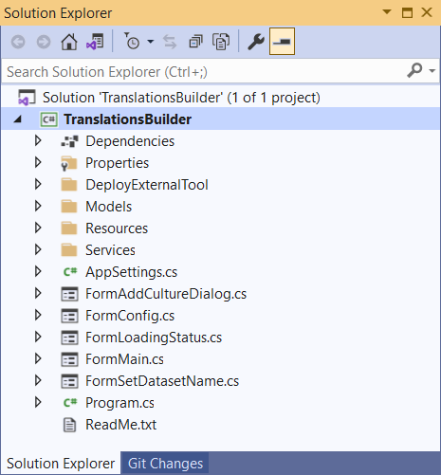

The **TranslationsBuilder** project has been created using the [external tools integration support](https://docs.microsoft.com/en-us/power-bi/transform-model/desktop-external-tools) for Power BI Desktop. Once the **TranslationsBuilder** application has been deploy on a Windows computer, you can launch it directly from Power BI Desktop using the **External Tools** tab in the ribbon.

You can deploy **TranslationsBuilder** as an external tool on a computer where you've already installed Power BI Desktop. You deploy an external tool by copying a JSON file with an extension of **pbitool.json** into a well-known folder location which is inspected by Power BI Desktop at startup. The **TranslationsBuilder** project contains a JSON deployment file named **translationsbuilder.pbitool.json**.

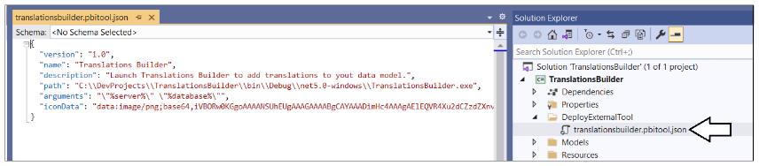

Let's walk through the steps to deploy **TranslationsBuilder** as an external tool for Power BI Desktop, First, you must build the project to generate the executable program file named **TranslationsBuilder.exe**. Next, you must update the **path** property in **translationsbuilder.pbitool.json** so it points to the location path for **TranslationsBuilder.exe**. Third, you must copy the file named **translationsbuilder.pbitool.json** to the **External Tools** folder located at the following path.

C:\Program Files (x86)\Common Files\Microsoft Shared\Power BI Desktop\External Tools

The **External Tools** folder might already contain other deployment files for other external tools such as Tabular Editor.

Once you have copied the **translationsbuilder.pbitool.json** file to the **External Tools** folder, the **TranslationsBuilder** tile should appear in Power BI Desktop on the **External Tools** tab in the ribbon. Note that you must restart Power BI Desktop before you can see the effect. After a restart, you should see **TranslationsBuilder** in the **External Tools** tab in the ribbon.

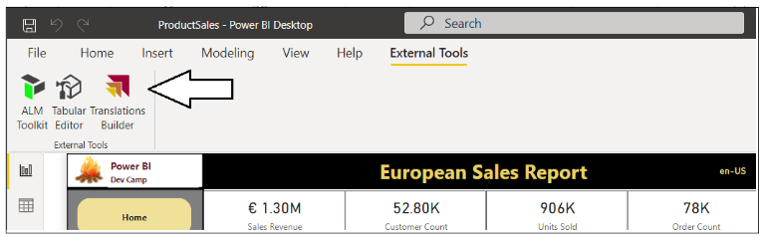

When you launch an external tool like **TranslationsBuilder**, the application is passed startup parameters including a connection string which can be used to establish a connection back to the dataset that's loaded in Power BI Desktop. This allows **TranslationsBuilder** to display dataset information and to provide commands to automate adding translations. **TranslationsBuilder** also provides a table grid down below which displays all the non-hidden dataset objects and their associated metadata translations.

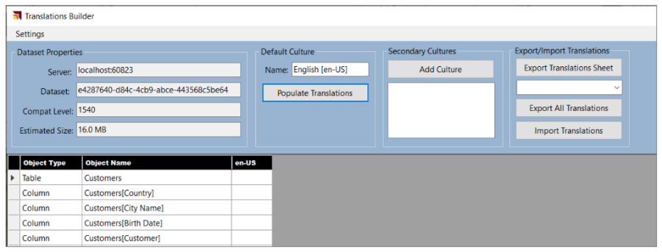

### Program with TOM in an External Tool

**TranslationsBuilder** is a developer sample created to demonstrate programming metadata translations using TOM. The **TranslationsBuilder** project contains a C# class named [**TranslationsManager**](https://github.com/PowerBiDevCamp/Multilanguage-Reports/blob/main/TranslationsBuilder/Services/TranslationsManager.cs) which contains the custom C# code which programs with TOM to create secondary cultures and to add metadata translations.

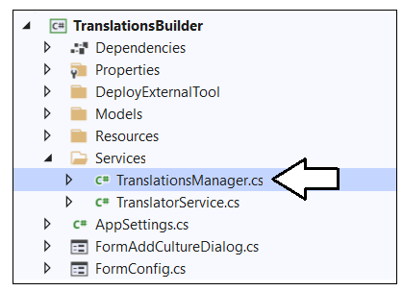

Whenever you open a PBIX file with a dataset definition, Power BI Desktop launches a local instance of Analysis Services. The programming model of TOM provides a top-level **Server** object which you can think of as your connection to a local instance of the Analysis Services. The **Server** object provides a **Databases** collection of **Database** objects. Each **Database** object has a **Model** property which provides access to tables, cultures and metadata translations.

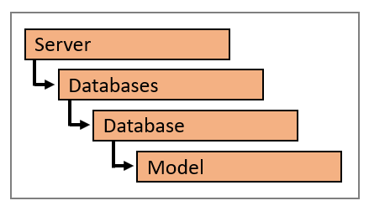

Each time Power BI Desktop starts a local instance of Analysis Service to load a dataset, it assigns what seems like a random port number (e.g. **50001**). You can construct a connection string using a path of **localhost** followed by the port number in a format that follows the pattern of **localhost:50001**. Once you know the port number of the local instance of Analysis Services, you can connect to the dataset loaded in that instance using the following code.

// connect to local Analysis Services engine running in Power BI Desktop session

Server server = new Server();

server.Connect("localhost:50001");

// With Power BI Desktop, server will contain extactly one database

Database dataset = server.Databases[0];

Model model = server.Databases[0].Model;

When using TOM to connect to Power BI Desktop, the **Databases** collection will always contain a single **Database** object. Therefore, you can access the **Database** object representing a dataset loaded into Power BI Desktop using **Datasets[0]**. Things are different when using TOM to connect to a workspace in the Power BI Service. In this case the **Server** object represents a Power BI workspace which can have more than one dataset. In this case, the **Datasets** collection can have more than one dataset so the syntax of **Datasets[0]** cannot be used reliably. Instead, you must access datasets by name.

Now let's examine how an external tool like **TranslationsBuilder** is able to obtain the connection string to connect to the **Server** object. When Power BI Desktop launches an external tool, it passes startup parameters which a connection string for the **Server** object and the **Database** name which is passed as a GUID.

Since **TranslationsBuilder** has been deployed as an **External Tool**, the application can examine its startup parameters to dynamically discover the **Server** connect string. The **TranslationsManager** class provides a [static constructor](https://github.com/PowerBiDevCamp/Multilanguage-Reports/blob/main/TranslationsBuilder/Services/TranslationsManager.cs#L19) that uses properties of the **AppSettings** class to initialize the a **Server** object and a **Model** object for the dataset that's open in the current session of Power BI Desktop.

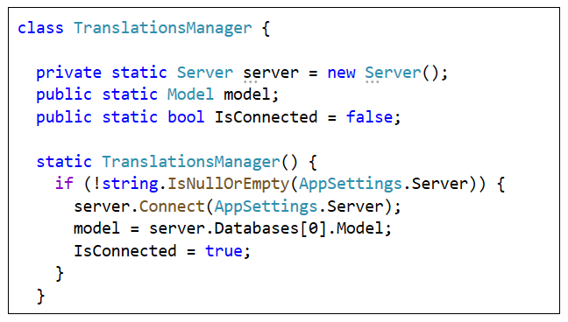

Once you acquire a reference to the **Model** object, it can be used to view or modify the dataset objects inside the dataset definition including tables, columns, measure and hierarchies. The **Model** contains a **Tables** collection and each **Table** object contains three important collections named **Columns**, **Measures** and **Hierarchies**.

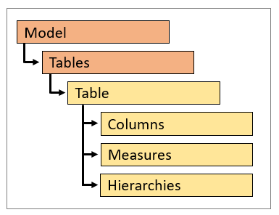

You can enumerate through the **Tables** collection of a **Model** object to discover what tables exist in a dataset definition. Within a **Table** object, you can further enumerate through three collections named **Columns**, **Measures** and **Hierarchies**.

foreach (Table table in model.Tables) {

// enumerate through tables one by one

Console.WriteLine("Table: " + table.Name);

// enumerate through columns

foreach (Column column in table.Columns) {

Console.WriteLine("Column: " + column.Name);

};

// enumerate through measures

foreach (Measure measure in table.Measures) {

Console.WriteLine("Measure: " + measure.Name);

};

// enumerate through hierarchies

foreach (Hierarchy hierarchy in table.Hierarchies) {

Console.WriteLine("Hierarchy: " + hierarchy.Name);

};

}

It is important that you understand how to enumerate tables, columns, measure and hierarchies in this fashion when you need to add metadata translations. That's because tables, columns, measure and hierarchies are the dataset object where you need to add these metadata translations.

The **TranslationsBuilder** application has been designed to store and retrieve persistent application settings using the [Application Settings support in Windows Forms](https://docs.microsoft.com/en-us/dotnet/desktop/winforms/advanced/application-settings-for-windows-forms?view=netframeworkdesktop-4.8). The **TranslationsBuilder** application provides a top-level **AppSettings** class with a set of static properties as shown in the following screenshot. If you are curious, you can examine the implementation of these static properties in the [**AppSettings**](https://github.com/PowerBiDevCamp/Multilanguage-Reports/blob/main/TranslationsBuilder/AppSettings.cs#L10) class to see how to store and retrieve persistent property settings in a desktop application created using .NET.

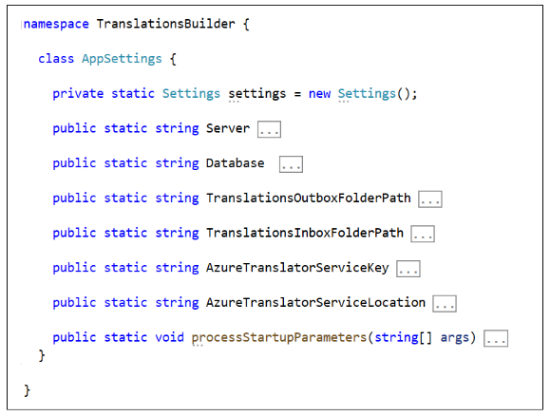

The **Server** property and **Database** property are used to track the target dataset to open. There are two other properties named **TranslationsOutboxFolderPath** and **TranslationsInboxFolderPath** which allow the user to customize where translation files are stored in the file system of the local computer. There are also two addition properties named **AzureTranslatorServiceKey** and **AzureTranslatorServiceLocation** used to store credentials for communicating with the Microsoft Translator service. The purpose of all of these properties in the **AppSettings** class will be explained in later sections of this article.

The **TranslationsBuilder** application makes it possible for a user to modify any of these application settings by invoking the **Configure Settings…** command from the **Settings** menu to display the **Configuration Options** dialog.

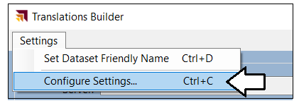

The **Configuration Options** dialog prompts the user with a simple form which can be used to view or update any of the application settings. There is also a **Save Changes** button which allows the user to persist their changes locally.

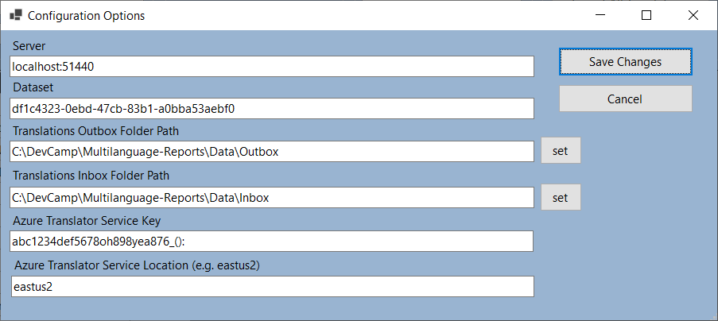

### Use Annotations to Store Custom Property Values

Before diving further into programming metadata translations, it's time to examine using the [Annotations feature](https://docs.microsoft.com/en-us/dotnet/api/microsoft.analysisservices.tabular.annotation?view=analysisservices-dotnet) made available through TOM. Let's begin by asking a simple question. ***What is an annotation?***

You can think of an annotation as a custom property or custom tag that you add into a dataset definition. You can add an annotation to a dataset object such as a table, column, measure or hierarchy. You can also add an annotation directly to the **Model** object if you'd like to create a custom property that is tracked at the dataset level. Here's an example of creating a new **Annotation** object and adding it to the **Annotations** collection of the **Model** object.

Annotation annotation1 = new Annotation { Name = "MyFirstAnnotation", Value = "Hello Annotations" }

model.Annotations.Add(annotation1);

model.SaveChanges();

As you can see, an annotation is really just a name/value pair that can be added to a dataset object to create a custom property. The use of annotations can lead to innovative designs where you're able to track whatever custom metadata you need within a dataset definition. The **TranslationsBuilder** application demonstrates the use of annotations by adding support to track a friendly dataset name so users do not have to rely upon dataset names in the form of GUIDs.

If you examine the code inside the **TranslationsManager** class, you can see it contains a const string field named [**DatasetAnnotationName**](https://github.com/PowerBiDevCamp/Multilanguage-Reports/blob/main/TranslationsBuilder/Services/TranslationsManager.cs#L27) and a static property named [**DatasetName**](https://github.com/PowerBiDevCamp/Multilanguage-Reports/blob/main/TranslationsBuilder/Services/TranslationsManager.cs#L29) as shown in the following code listing.

const string DatasetAnnotationName = "FriendlyDatasetName";

public static string DatasetName {

get {

if (model.Annotations.Contains(DatasetAnnotationName)) {

return model.Annotations[DatasetAnnotationName].Value;

}

else {

return model.Database.Name;

}

}

set {

if (model.Annotations.Contains(DatasetAnnotationName)) {

model.Annotations[DatasetAnnotationName].Value = value;

}

else {

model.Annotations.Add(new Annotation { Name = DatasetAnnotationName, Value = value});

}

model.SaveChanges();

}

}

Now that you have seen the completed implementation of the **DatasetName** property, let's review the code in the **get** block and the **set** block so you can see the general pattern involved when programming annotations with TOM.

The **get** block of the **DatasetName** property checks to see if an annotation with a name of **FriendlyDatasetName** has already been created. If the annotation exists, the property returns the **Value** property of the **Annotation** object. If there is no **Annotation** with the name of **FriendlyDatasetName**, the property implementation falls back on the **Name** property of the **Database** object which is typically tracked using the less-than-friendly GUID value.

get {

if (model.Annotations.Contains(DatasetAnnotationName)) {

return model.Annotations[DatasetAnnotationName].Value;

}

else {

return model.Database.Name;

}

}

The **set** block of the **DatasetName** property has been written to update the annotation value. As you can see from the following code, you must first determine whether the annotation already exists. If the annotation exists, you update its **Value** property. If the annotation does not yet exist, you must create a new **Annotation** object and add it to the **Annotations** collection of the **Model** object.

set {

if (model.Annotations.Contains(DatasetAnnotationName)) {

model.Annotations[DatasetAnnotationName].Value = value;

}

else {

model.Annotations.Add(new Annotation { Name = DatasetAnnotationName, Value = value});

}

model.SaveChanges();

}

**IMPORTANAT**: Calling **SaveChanges** only updates the dataset loaded into memory in a session of Power BI Desktop. You must go to Power BI Desktop and save your work there for the changes to be persisted to the underlying PBIX file.

When you add an annotation in this fashion, the annotation becomes part of the metadata for the dataset definition. The following screenshot shows how this annotation is serialized within the **BIM** file for a dataset definition.

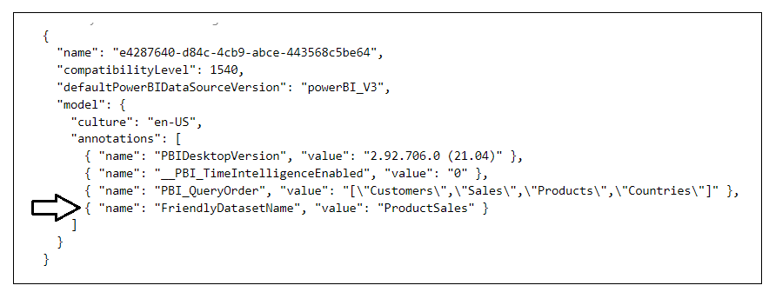

From this screenshot, you can see that Power BI Desktop uses annotations to track its own custom properties within a dataset definition with annotations such as **PBIDesktopVersion**, **PBI_QueryOrder** and **__PBI_TimeIntelligenceEnabled**.

Now, let's examine how using an annotation like this can improve the user experience of an external tool. When you first open a dataset in the **TranslationsBuilder** application, the **Dataset** name will be displayed as a GUID value.

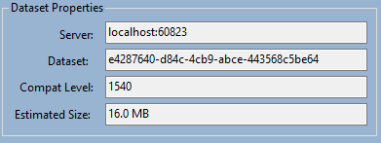

The vast majority of humans have trouble memorizing or recognizing GUID values and would generally prefer more friendly names. Therefore, the **TranslationsBuilder** application provides the ability to replace the GUID for the dataset name with a more friendly name. To change the dataset name, you can invoke the **Set Friendly Dataset Name** command from the **Settings** menu to display the **Set Dataset Name** dialog.

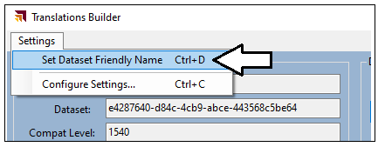

When promoted by the **Set Dataset Name** dialog, you can add a friendly dataset name and then click **Save**.

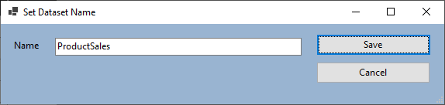

When you click **Save**, the **TranslationsBuilder** application will save the **Name** value as an annotation and display this friendly name instead of the GUID.

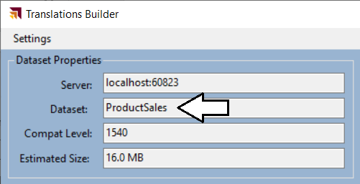

Remember TOM code can update the dataset loaded into memory in Power BI Desktop. However, it cannot persist the changes to the underlying PBIX file. You must save your changes to in Power BI Desktop to update the PBIX file.

As you will see later, the **TranslationsBuilder** application uses the dataset name when it generates file names during the translation export process. This makes it possible to generate files with more meaningful names like this.

ProductSales-Translations-Spanish.csv

You can see why this is better than generating file names with GUIDs that looks like this.

e4287640-d84c-4cb9-abce-443568c5be64-Translations-Spanish.csv.

Let's summarize what you have learned in this section. Annotation provide a great way to track custom properties inside a dataset definition. In the **TranslationsBuilder** application, annotations are used to track a friendly dataset name. However, annotations can also be used to track custom property values for a table, column, measure or hierarchy. Your takeaway should be that annotations provide a very powerful design dimension that is really only limited by your imagination.

### Add Secondary Cultures to a Dataset

The set of dataset objects that support adding metadata translations include **Table** objects, **Column** objects, **Measure** objects and **Hierarchy** objects. For each of these dataset object, you can add translations using three different properties which include the **Caption** property, the **Description** property and the **DisplayFolder** property. You can think of the **Caption** property of a dataset object as the display name which is seen by users.

Before you can begin to add translations to a dataset object, you must understand the purpose of **Culture** objects. In a new dataset definition, there will be a single **Culture** object based on a default language and a default locale. In the TOM programming model, the **Model** object contains a text-based **Culture** property which indicates the default culture for the dataset and a **Cultures** collection which contains a set of one or more **Culture** objects.

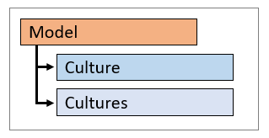

The **ProductSales.pbix** developer sample has default culture name of **en-US**. If you want to determine the default culture name of a dataset, you can examine the **Culture** property of the **Model** object.

string defaultCultureName = model.Culture;

Let's say you need to obtain a reference to the **Culture** object for the default culture. You can write the following code to access the default **Culture** object by accessing it through the **Cultures** collection using the culture name as an index key.

Culture defaultCulture = model.Cultures[model.Culture];

In a new dataset definition, the **Cultures** collection contain a single **Culture** object based on the default culture. You must explicitly add new **Culture** objects to the **Cultures** collection to support secondary languages. Here is an example of adding a secondary culture to support adding metadata translations in Spanish.

model.Cultures.Add( new Culture { Name = "es-ES" } );

model.SaveChanges();

Remember that calling **SaveChanges** doesn't update the PBIX project file. After making changes to a dataset using an external tool such as **TranslationsBuilder**, you still need to return to Power BI Desktop and save your changes there.

The **TranslationsBuilder** application allows the user to add secondary cultures. To accomplish this, click the **Add Culture** button to display the **Add Culture** dialog. Next, select a culture from the list and click the **Add Culture** button.

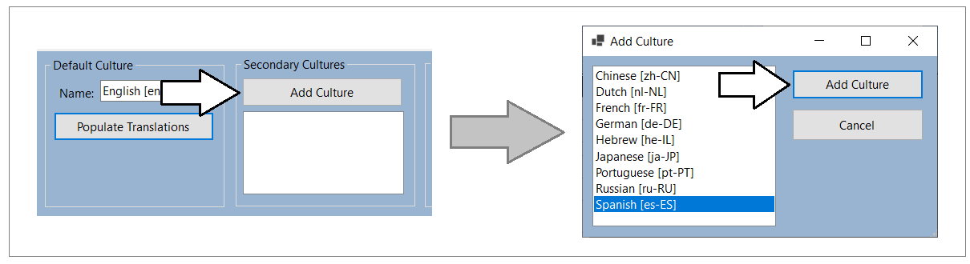

After adding new cultures to a dataset definition, you should be able to see them in the list box in the **Secondary Cultures** section. You should also notice that a new column appears for each culture in the table grid shown below.

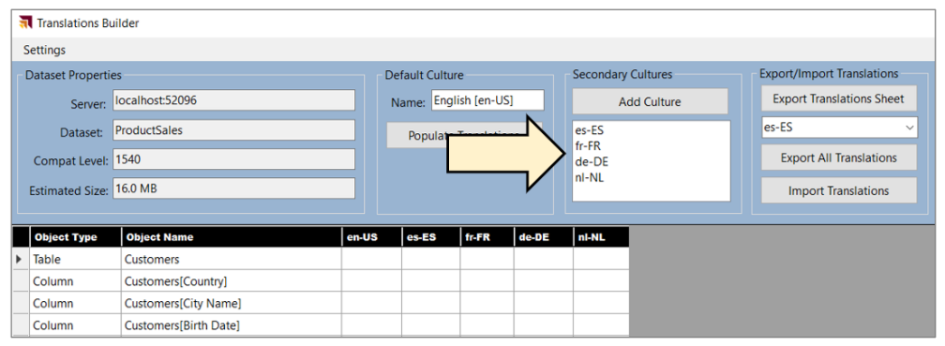

**TranslationsBuilder** uses the following code to discover which secondary cultures exist within the current dataset.

public static List<string> GetSecondaryCulturesInDataModel() {

List<string> secondaryCultures = new List<string>();

foreach (var culture in model.Cultures) {

if (!culture.Name.Equals(model.Culture)) {

secondaryCultures.Add(culture.Name);

}

}

return secondaryCultures;

}

### Add Metadata Translations to a Dataset Object

A key point to understand is that every metadata translation must be added within the scope of a **Culture** object that already exists in the current dataset definition. Each **Culture** object provides a collection property named **ObjectTranslations** which exposes a **SetTranslation** method which is used to add new metadata translations.

When calling the **SetTranslation** method, you must pass three parameters including the target dataset object, the target property and the value of the translation. Let's start with the easiest case when adding a translation to the default culture for a dataset object such as a table.

// acquire reference to datase object

Table tableCustomers = model.Tables["Customers"];

// get default Culture object

Culture culture = model.Cultures[model.Culture];

// call SetTranslation to add translation for Caption property of the dataset object

culture.ObjectTranslations.SetTranslation(tableCustomers, TranslatedProperty.Caption, tableCustomers.Name);  
  
// save changes back to model

model.SaveChanges();

In the call to **SetTranslation** shown above, you can see that the first parameter is passed as a **Table** object. It is also possible to pass other types of dataset objects in the first parameter including a **Column** object, a **Measure** object or a **Hierarchy** object. The second parameter indicates the target property type which can be passed as an enumeration value of **Caption**, **Description** or **DisplayFolder**. The third parameter passes the value of the translation being created.

The **TranslationsManager** class provides the [**PopulateDefaultCultureTranslations**](https://github.com/PowerBiDevCamp/Multilanguage-Reports/blob/main/TranslationsBuilder/Services/TranslationsManager.cs#L95) method which automates the process of adding **Caption** property translations for all non-hidden tables, columns, measures and hierarchies in the current dataset definition. For the default culture, you can use dataset object names when adding **Caption** property translations.

public static void PopulateDefaultCultureTranslations() {

// get default Culture object

Culture culture = model.Cultures[model.Culture];

foreach (Table table in model.Tables) {

if (!table.IsHidden) {

// set translation for table

culture.ObjectTranslations.SetTranslation(table, TranslatedProperty.Caption, table.Name);

// set translations for all non-hidden columns

foreach (Column column in table.Columns) {

if (!column.IsHidden) {

culture.ObjectTranslations.SetTranslation(column, TranslatedProperty.Caption, column.Name);

}

};

// set translations for all non-hidden measures

foreach (Measure measure in table.Measures) {

if (!measure.IsHidden) {

culture.ObjectTranslations.SetTranslation(measure, TranslatedProperty.Caption, measure.Name);

}

};

// set translations for all non-hidden hierarchies

foreach (Hierarchy hierarchy in table.Hierarchies) {

if (!hierarchy.IsHidden) {

culture.ObjectTranslations.SetTranslation(hierarchy, TranslatedProperty.Caption, hierarchy.Name);

}

};

}

model.SaveChanges();

}

}

The **TranslationsBuilder** application provides a **Default Culture** section with a **Populate Translations** button. When you click this button, it executes **PopulateDefaultCultureTranslations**. After clicking **Populate Translations**, you should be able to view the metadata translations that have been added into the default culture as shown in the table grid below.

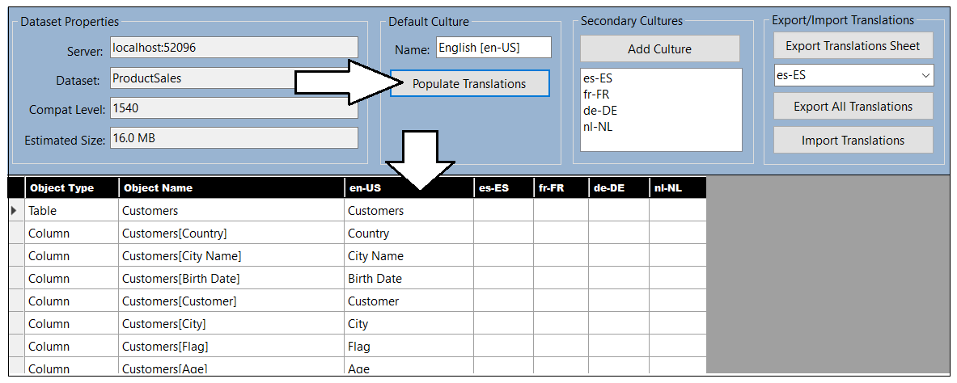

The **TranslationsManager** class contains a method named [**GetTranslationsTable**](https://github.com/PowerBiDevCamp/Multilanguage-Reports/blob/main/TranslationsBuilder/Services/TranslationsManager.cs#L408). You can review this method implementation to see the code that programs with TOM to enumerate through both cultures and non-hidden dataset objects to provide the data to populate the table grid.

### Generate Machine Translations using Azure Translator Service

One of the biggest challenges in building multi-language reports is managing the language translation process. You must ensure that the quality of translations is high and that the translated names of tables, columns, measures and labels do not lose their meaning when translated to another language. In most cases, acquiring quality translations will require human translators to create or at least review translations as part of the multi-language report development process.

While human translators are an essential part of the end-to-end process, it can take a long time to send out translation files to a translation team and then wait for them to come back. With all the recent industry advances in Artificial Intelligence (AI), you also have the option to generate machine translations using a Web API that can be called directly from an external tool such as **TranslationsBuilder**. If you initially generate machine translations for each secondary culture you need to support, that will give you something to work with while waiting for a translation team to return their high-quality human translations.

While machine translation are not always guaranteed to be high quality, they do provide value in the multi-language report development process. First, they can act as translation placeholders so you can begin your testing by loading reports using secondary languages to see if there are layout issues or unexpected line breaks. Machine translations can also provide human translators with a better starting point as they just need to review and correct translations instead of creating every translation from scratch. Finally, machine translations can be used to quickly add support for languages in scenarios where there are legal compliance issues and organizations faces fines or litigation for non-compliance.

The **TranslationsBuilder** application includes support to generate machine translations with the [Azure Translator service](https://docs.microsoft.com/en-us/azure/cognitive-services/translator/translator-info-overview) that is part of Azure Cognitive Services. This Web API makes it possible to automate enumerating through dataset objects to translate dataset object names from the default language to secondary languages. The diagram below shows the details of executing a Translator service API request to convert a table name from English (en) to Dutch (nl).

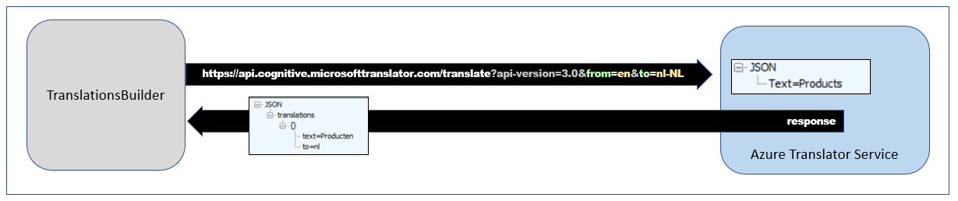

If you'd like to test out the support in **TranslationsBuilder** for generating machine translations, you will require an Azure subscription. An Azure subscription is required because you must create your own instance of the Translator service in Microsoft Azure. Once you have created an instance of the Translator service, you must determine its location and acquire an application key before you can successfully call to it from the **TranslationsBuilder** application.

The Azure Translator service does not support anonymous API calls. Instead, you must acquire an application keys which acts as a security credential because it allows you to execute secure Web API calls to the Translator service. When working with an instance of the Translator service in the Azure portal, you can navigate to the **Keys and Endpoint** page where you can view and acquire an application key.

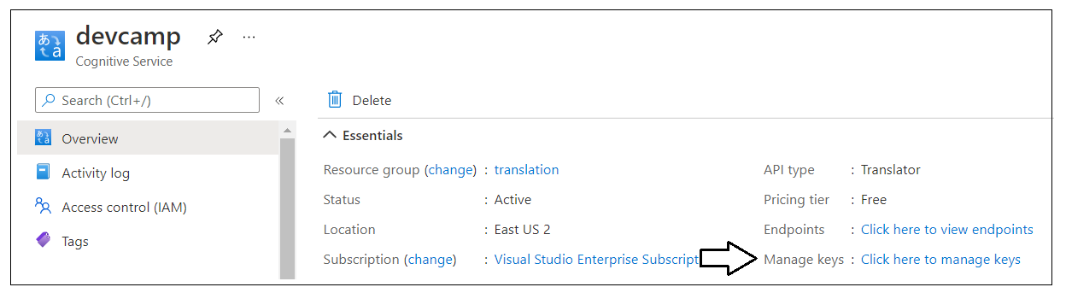

On the **Keys and Endpoint** page, you can copy the application key and then paste it into the **Configuration Options** dialog in **TranslationsBuilder**. You will also need to copy the service **Location** and paste that value into the **Configuration Options** dialog as well.

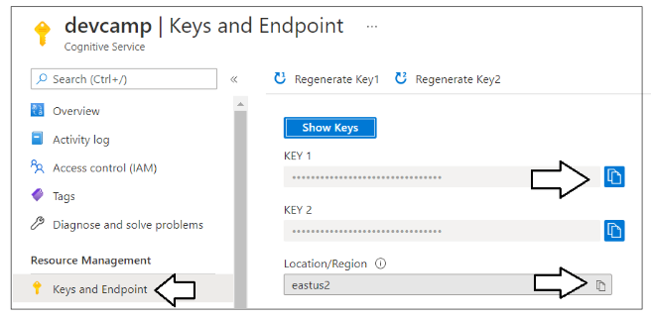

Once you have copy-and-pasted the application key and the location for your Translator service instance, you can save your changes in the **Configuration Options** dialog and begin generating machine translations.

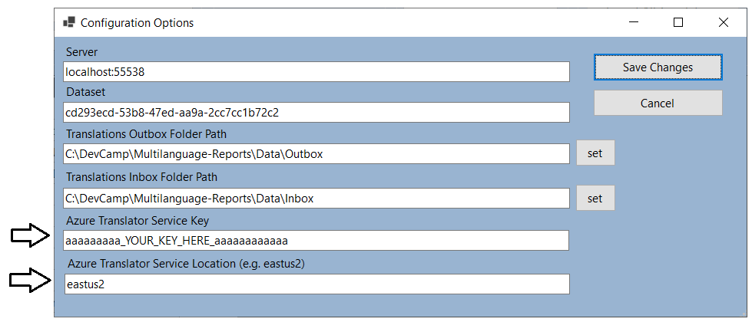

The **TranslationsBuilder** project contains a class named [**TranslatorService**](https://github.com/PowerBiDevCamp/Multilanguage-Reports/blob/main/TranslationsBuilder/Services/TranslatorService.cs) which contains code to manage the low-level details of calling the Translator service API to translate text values from one language to another. The **TranslatorService** class provides the public static method named [**TranslateContent**](https://github.com/PowerBiDevCamp/Multilanguage-Reports/blob/main/TranslationsBuilder/Services/TranslatorService.cs#L63) which can be called to translate text values.

The **TranslateContent** method accepts two parameters. The first parameter is a string value containing the text to be translated. The second parameter is used to pass the target language for translation. The implementation of **TranslateContent** abstracts calling the Translator server Web API and does the work to translate text value from the default culture language to the target language. Here is an example of calling **TranslateContent** to translate a text value from the default culture language (e.g. English) to the language of Spanish in the locale of Spain.

String translatedSpanishName = TranslatorService.TranslateContent("Customers", "es-ES");

The **TranslationsBuilder** application contains a **Machine Translations** section with a **Generate Translations** button. Note that the **Machine Translations** section will not be visible until you have added an application key and a location for the Azure Translation Service in the **Configuration Options** dialog. Once you have configured **TranslationsBuilder** with an application key and a location for your Translator service instance, you should be able to select a target culture with the language you want and click the **Generate Translations** button to generate machine translation for that language.

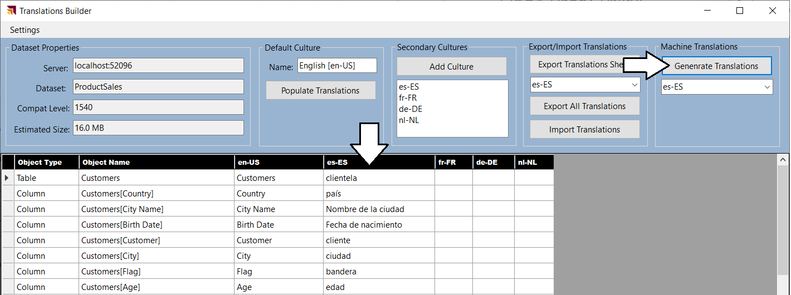

The **TranslationsManager** class contains a static method named [**PopulateCultureWithMachineTranslations**](https://github.com/PowerBiDevCamp/Multilanguage-Reports/blob/main/TranslationsBuilder/Services/TranslationsManager.cs#L138) which takes a single string parameter for the target language. The implementation of this method adds new machine-generated translations for every non-hidden table, column, measure and hierarchy in the dataset. You can walk through the code in the following listing to see how to add a full set of translations for a new secondary culture.

public static void PopulateCultureWithMachineTranslations(string CultureName) {

// add secondary culture to model if it doesn't already exist

if (!model.Cultures.ContainsName(CultureName)) {

model.Cultures.Add(new Culture { Name = CultureName });

}

// get target Culture object where translations will be added

Culture culture = model.Cultures[CultureName];

// enumerate through all non-hidden tables, columns, measures and hierachies

foreach (Table table in model.Tables) {

if (!table.IsHidden) {

// (1) get machine translation for table name and use it set translation for Caption property

String translatedName = TranslatorService.TranslateContent(table.Name, CultureName);

culture.ObjectTranslations.SetTranslation(table, TranslatedProperty.Caption, translatedName);

// (2) get machine translations for visible column names and use them to set translations

foreach (Column column in table.Columns) {

if (column.IsHidden) {

translatedName = TranslatorService.TranslateContent(column.Name, CultureName);

culture.ObjectTranslations.SetTranslation(column, TranslatedProperty.Caption, translatedName);

}

};

// (3) get machine translations for visible measure names and use them to set translations

foreach (Measure measure in table.Measures) {

if (!measure.IsHidden) {

translatedName = TranslatorService.TranslateContent(measure.Name, CultureName);

culture.ObjectTranslations.SetTranslation(measure, TranslatedProperty.Caption, translatedName);

}

};

// (4) get machine translations for visible hierachy names and use them to set translations

foreach (Hierarchy hierarchy in table.Hierarchies) {

if (!hierarchy.IsHidden) {

translatedName = TranslatorService.TranslateContent(hierarchy.Name, CultureName);

culture.ObjectTranslations.SetTranslation(hierarchy, TranslatedProperty.Caption, translatedName);

}

};

}

}

// (5) Save changes to the underlying dataset

model.SaveChanges();

}

You now seen how the **TranslationsBuilder** application can automate common localization tasks such as adding secondary cultures and generating machines translations. This will allow you to reach you first milestone of adding the first round of translations so you can begin testing them by loading a localized report using different languages.

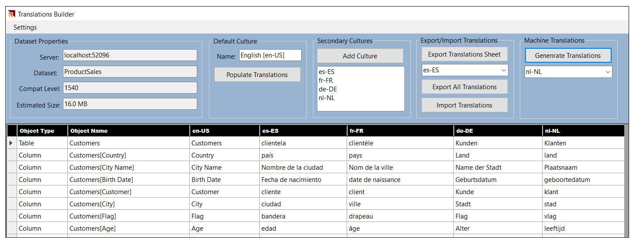

Once you have added metadata translations for a secondary culture, you can test your work by publishing the dataset and report to a workspace in the Power BI Service. Remember that the workspace must be associated with a Premium capacity or a Power BI Embedded capacity or metadata translations will not load as expected. To load the metadata translations for a specific language, you can add the **language** query string parameter at the end of the URL for a report. For example, you can load a report with Spanish translations by adding a **language** query string parameter of **es** or **es-ES**.

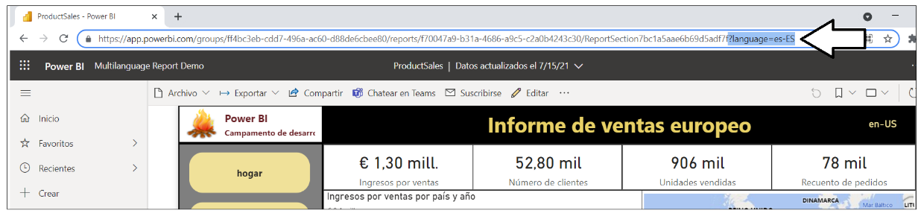

There is one important thing to note about loading reports with the **language** query string parameter. At the time of this writing in July of 2021, loading a report with the **language** query string parameter does not change the behavior of the **UserCulture** function in DAX. If you have written measures which use the **UserCulture** function to conditionally return different values depending on the user's language or locale, they will not work correctly. Instead you must configure the browser setting for user language and user locale to effectively test measures that call **UserCulture**. Alternatively, you can test reports using Power BI embedding where you have completed control over which language and locale is used to load a report.

### Enable Human Workflows for Translation using Export and Import

Another important consideration when building multi-language reports involves the human aspect of translating text values from one language to another. While it's possible to generate the first round of metadata translations using machine translations, it's likely you will eventually need to integrate those friendly carbon-based life forms (i.e. people) who play the roles of translators to generate high quality translations. Furthermore, you cannot expect that people who work as professional translators will be able to use an advanced Power BI data modeling tool like the Tabular Editor.

While it's theoretically possible to have human translators work on files generated by the **Export Translations** command of the Tabular Editor, the JSON-based format will likely be rejected by professional translator teams due to it being a non-standard file format that is hard to work with. Once you begin writing custom code with TOM, however, you can generate the translation files that are sent out to a translation team using whatever file format they required.

If you are working with a professional translation team, you might be requires to generate translation files in a standard translation format such as RESX files or XLIFF files. Depending on the requirements of the translator team, you might be able to generate translations files in easy-to-use formats such as CSV files or XLSX files. The **TranslationsBuilder** application provides an **Export Translation Sheet** command which demonstrates how to generate a translation sheet for a human translator using a simple CSV format.

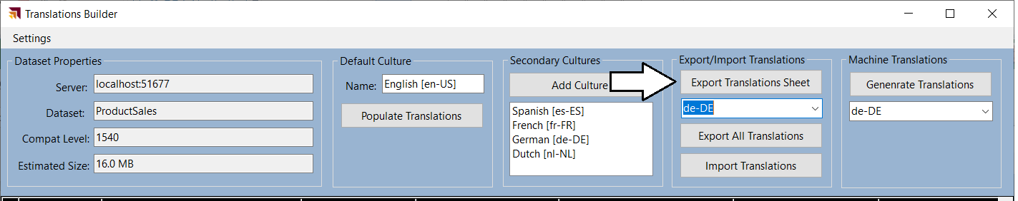

When you click the **Export Translation Sheet** button, the **TranslationsBuilder** application generates a CSV file for the selected language using a naming format (e.g. **ProductSales-Translations-German.csv**) which includes the dataset name and the language for translation. After generating the file and saving it to the location of **TranslationsOutboxFolderPath** the **TranslationsBuilder** application will then open the translation sheet in Microsoft Excel.

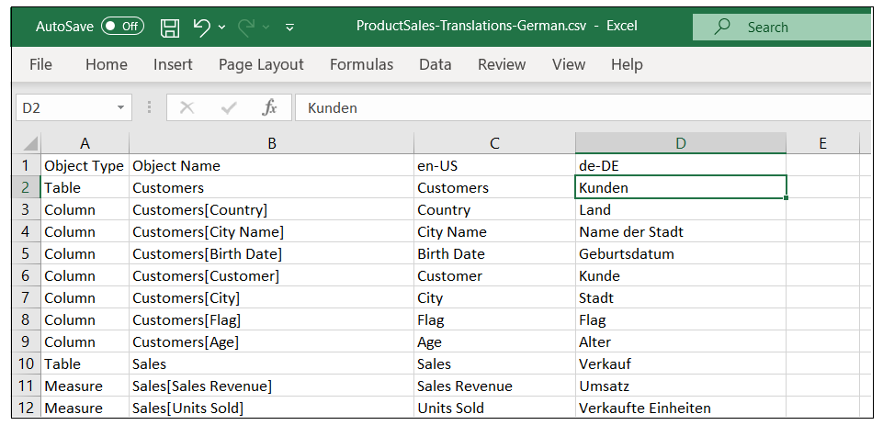

Once these translation files have been generated, they can be sent to the translation team. Once these translations files have been edited and returned with the high-quality human translations, you can then use the **Import Translations** command to important these human translations which effectively overwrite the machine translations.

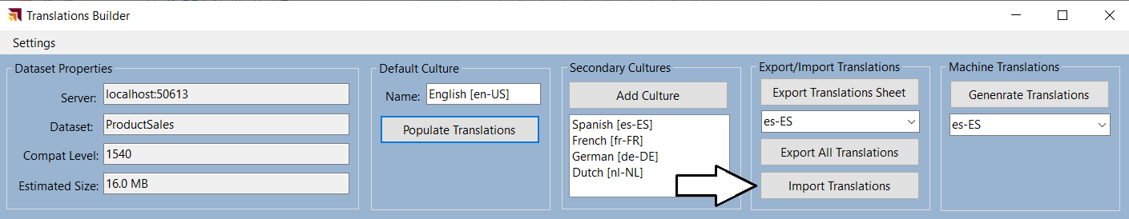

### Embed Power BI Reports with Specific Languages and Locales

If you are developing with Power BI embedding, you can use the Power BI JavaScript API to load reports with a specific language and locale using the **localeSettings** parameter. The **localeSettings** parameter is an object with a **language** property and a **formatLocale** property that can be included as part of the **config** object that is passed in the call to **powerbi.embed** as shown in the following code.

let config = {

type: "report",

id: reportId,

embedUrl: embedUrl,

accessToken: embedToken,

tokenType: models.TokenType.Embed,

localeSettings: { language: "fr-FR", formatLocale: "fr-FR" }

};

let report = powerbi.embed(reportContainer, config);

When you embed reports using an explicit value for the **formatLocale** parameter, the **UserCulture** function will work correctly. That means you can write and test measures that conditionally return values based on the user's locale. The following screenshot shows where **TranslationsBuilder** displays the return value of the **UserCulture** function.

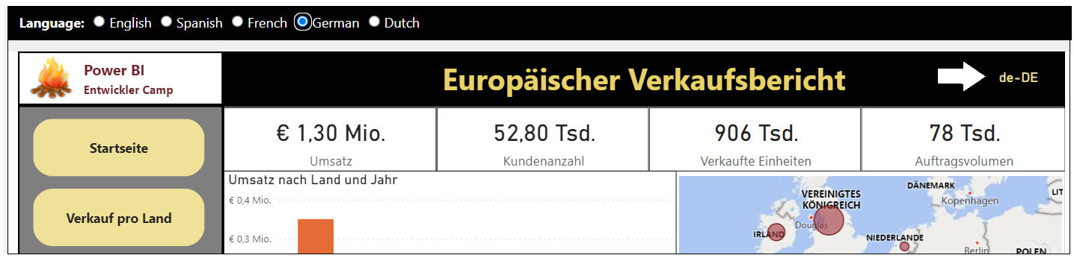

## Design and Implement a Content Translation Strategy

While all multi-language reports will require metadata translations, you cannot assume the same for content translations. Some projects will require content translations and others will not. In order the determine whether your project will require content translations, you'll need to think through the use cases you plan to support with your reporting solution. You will find that adding support for content translations involves a good deal of planning and effort. You might decide to only support content translations if they are a hard requirement for your project.

Implementing content translations is quite different from implementing metadata translations. They are different because Power BI doesn't offer any localization features to assist you with content translations. Instead, you must implement content translations with your own design by extending a dataset definition with fundamental building blocks such as tables, columns, measures and filters. This article walks through one possible solution for implementing content translations by examining how this requirement is met in the **ProductSales.pbix** developer solution.

### Determine Whether Your Solution Requires Content Translations

To determine whether you need to implement content translations, start by thinking about how your reporting solution will be deployed and think about the use case for its intended audience. That leads to a key question. **Will you have people who speak different languages looking at the same database instance?**

Imagine a scenario where you are developing a report template for a SaaS application with a well-known database schema. Now let's say some customer maintain their database instance in English while others maintain their database instances in other languages such as Spanish or German. There is no need to implement content translation in this use case as the data from any database instance only needs to be viewed by users in a single language.

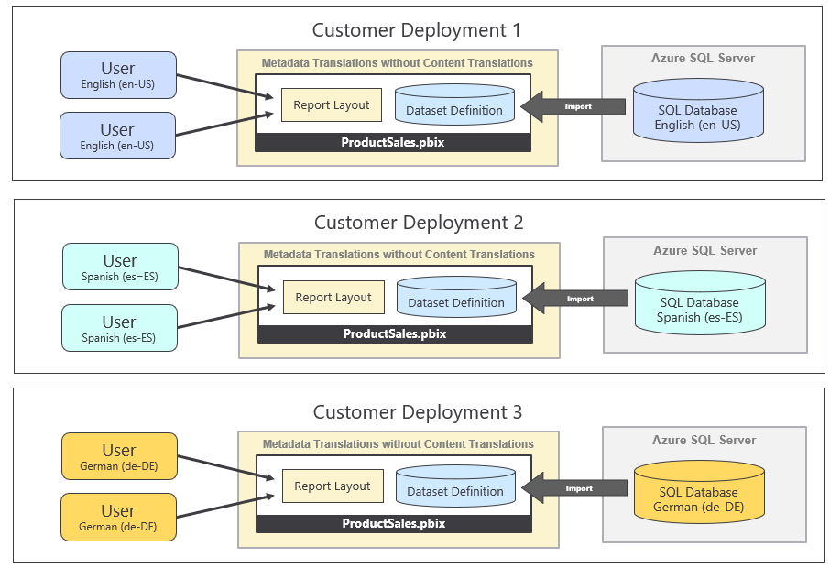

The important observation is that each customer deployment uses a single language for its database and all its users. Metadata translations must be implemented is this use case so you can deploy a single version of the PBIX file across all customer deployments. However, there is no need to implement content translations when no database instance ever needs to be viewed in multiple languages.

Now let's examine a different use case which introduces the requirement for content translations. This is the use case for the **ProductSales.pbix** developers sample which involves a single database instance containing sales performance data across several European countries. This reporting solution has the requirement to display its report in different languages while the data being analyzed is coming from a single database instance.

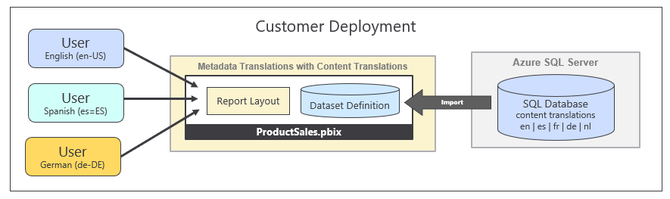

Once again, the key question to ask is whether you will have people who speak different languages looking at the same database instance. If the answer to that question is ***NO***, then you will not be required to implement content translations. If the answer to that question is ***YES***, then you should ask additional questions because there are other consideration you should think through before deciding whether it make sense to implement content translations.

When considering to implement content translation, you should examine the text-based columns which are candidates for translation to determine how hard will it be to translate those text value to secondary languages. Columns with short text values for things like product names, product categories and country names are a good candidates for content translation because the values are short and easy to translate. What if you have a column for product descriptions where each row has two to three sentences of text. While you can provide translations for these product descriptions, they will require more effort to generate high quality translations. In general, columns with longer text values are less ideal as candidates for content translation.

You should also consider the number of distinct column values that will require translation. You can easily translate product names in a database that holds 100 products. You can probably translate product names when the number gets up to 1000. However, what happens if the number of translated values reaches 10,000 or 100,000. Your translation team might have trouble scaling to handle that volume of translation.

You also have to consider that implementing content translation might require on-going maintenance. Every time someone adds a new record to the underlying database, you might be required to add new content translations for it. This is very different from implementing metadata translations where you create a finite number of translation for database objects and your work is done. Metadata translations don't require on-going maintenance as long as the underlying dataset schema remains the same.

In summary, there are many factors that go into deciding whether you should implement content translations or not. You must decide whether you can afford to spend the time it takes to implement content translations properly or whether just implementing metadata translations goes far enough. If your primary goal is to make your reporting solution compliant with laws or regulations, you might find that just implementing metadata translations is all you need.

### Modify the Dataset Design to Support Content Translation

Long before Microsoft introduced Power BI, software developers around the world have been building multi-language applications that support content translation. After two decades of designing and refining various database designs, several common design patterns have emerged as industry best practices to support content translation. Some of these design patterns involve adding a new table column for each language while other design patterns involve adding a new table row for each language. Each approach has its benefits and its drawbacks when compared to the other.

Currently, there is a data modeling limitation with DAX and the VertiPaq engine which makes it impractical to implement a content translation scheme based on adding a new column for each language. The specific limitation is that calculated columns are evaluated at dataset load time and do not yet support dynamic evaluation. While Microsoft has plans to update DAX and the VertiPaq engine to support calculated columns with dynamic evaluation, there is currently no timeline for when this feature will be available in Preview or when it will reach GA.

Until dynamic column support is added to Power BI, it will be difficult to implement an efficient content translation scheme based on adding a column for each language. Currently, you would be required to use measures instead of columns but that approach is very limiting because measures do not provide row context. For example, measures cannot be used to supply values for the axes in a bar chart or line chart. Furthermore, measures cannot be used in the data roles of a legend or to filter data using slicers.

When it comes to implementing content translations in Power BI, this is a new frontier for the Power BI developer community. Finding the best design approach for implementing content translations for any particular project will require innovative thinking. Chris Webb from the Power BI Customer Advisory Team (PBICAT) wrote a [blog post](https://blog.crossjoin.co.uk/2021/02/21/implementing-data-as-well-as-metadata-translations-in-power-bi/) in February of 2021 which discusses an advanced design approach which uses DirectQuery datasets and new functionality of the [composite model](https://docs.microsoft.com/en-us/power-bi/transform-model/desktop-composite-models) to implement a solution for content translation.

The **ProductSales.pbix** developer sample demonstrates implementing content translation using row replication with an import-mode dataset. Consider a simple example of this pattern. Let's say the **Products** table contains two text columns named **Product** and **Category** and you'd like your report to support five different languages including English, Spanish, French, German and Dutch. For each product in the **Products** table, you need to generate five records where each record contains the product name and product category translated to a specific language. Whenever the report is loaded, a row filter is applied to the **LanguageTag** column so that users only see the rows for one of the supported languages at a time.

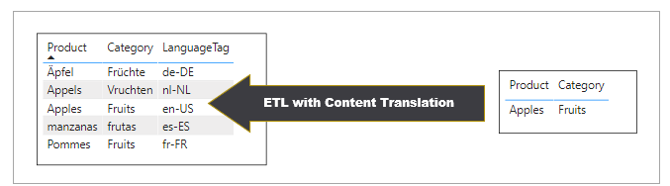`

When using row replication to implement content translations in Power BI, you must implement all the ETL logic to generate the extra rows with translated content. Many multi-language applications add support for content translation at the database level and use an ETL tool such as SQL Server Integration Services (SSIS) to generate the extra rows containing the translations. It's relatively easy to build a multi-language report in Power BI if the underling database has already been designed to support content translations. However, it can be quite a bit of work if you need to extend an existing database schema and develop the ETL logic to maintain content translations at the database level.

### Use Power Query to Generate Content Translation Rows

The **ProductSales.pbix** developer sample demonstrates implementing content translations using row replication. The ETL logic for this solution is implemented using Power Query and M code which leverages lookup tables with translated content to generate the extra rows from data in an Azure SQL database during the import process.

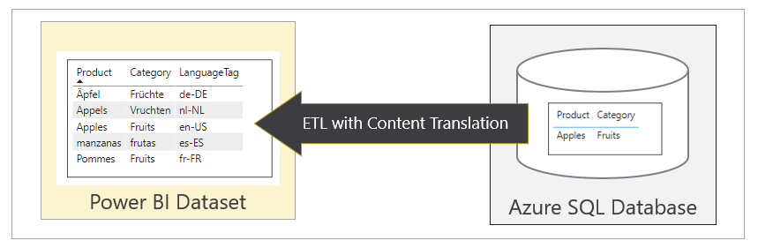

The following diagram shows the use case for the **ProductSales.pbix** developer sample. Note that this approach eliminates the need to redesign the underlying database to support content translations. Instead, all the ETL logic used to implemented content translations can be packaged and maintained inside a PBIX template file.

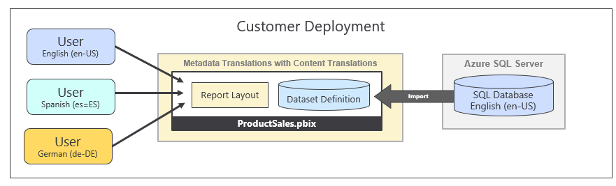

While implementing a content translation strategy with Power Query isn't always the right choice, it's great for scenarios where you don't have either the authority or the time it takes to add content translations support at the database level. If you do decide to use this strategy, you'll find the writing Power Query logic in the M programming language provides developers with a very elegant way to replicate rows with translated content during a dataset import operation.

If you'd like to review the ETL logic demonstrating how to implement content translations, you can open the PBIX solution file named [**ProductSales_03_ContentTranslations.pbix**](https://github.com/PowerBiDevCamp/Multilanguage-Reports/raw/main/PBIX/ProductSales_03_ContentTranslations.pbix) in Power BI Desktop and navigate to the Power Query Editor window to review the queries inside this project. The following screenshot shows all the queries in the project including the **Products** query whose output generates the **Products** table which loads into the project's data model.

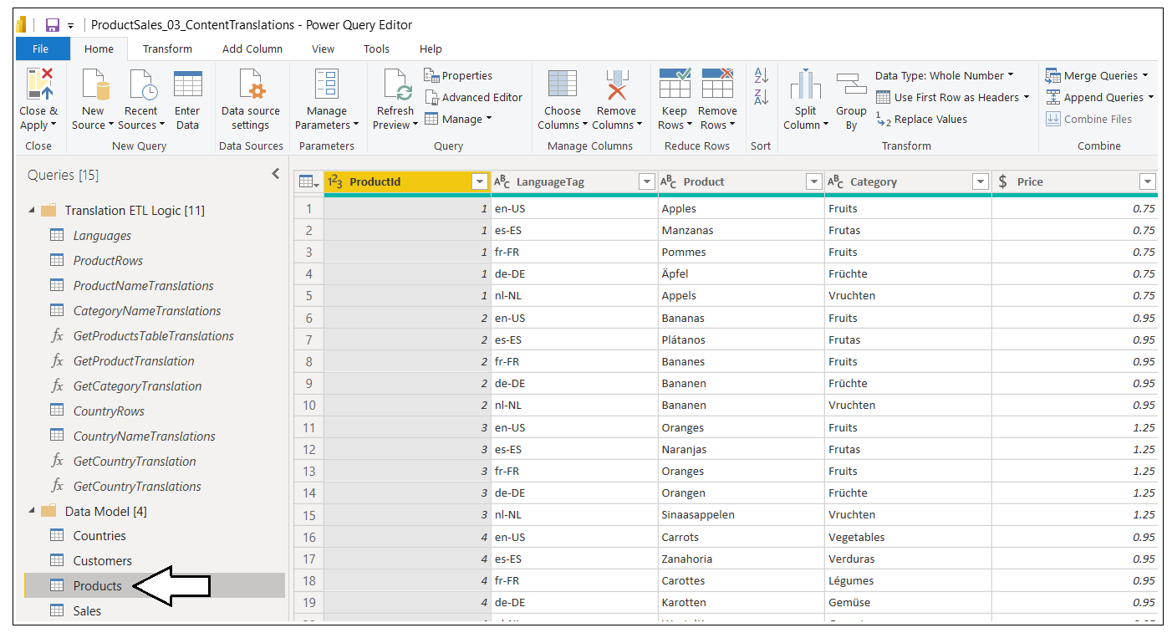

As you begin to work with this PBIX project in the Power Query Editor, you will be prompted to supply credentials for an Azure SQL Database named **EuropeanProductSales** with server path **devcamp.database.windows.net**. You should select a credential type of **Database** and then enter user name of **CptStudent** and a password of **pass@word1**. You must also set the privacy levels of all datasource to a level of **Organization** or select to ignore privacy levels.

Now it's time to step through some of the queries in this project so you can see how Power Query can be used to generate the extra rows required in the row replication pattern. Let's begin by examining the query named **Languages** which generates a table based on the following M code.

let

OutputSchema = type table [ LanguageTag=text, DisplayName=text, NativeName=text, SortOrder=number ],

Languages = #table(OutputSchema, {

{ "en-US", "English", "English", 1 },

{ "es-ES", "Spanish", "español", 2 },

{ "fr-FR", "French", "français", 3 },

{ "de-DE", "German", "Deutsch", 4 },

{ "nl-NL", "Dutch", "Nederlands", 5 }

})

in

Languages

The **Languages** query generates a table with a row for each language which will be used in the row expansion process.

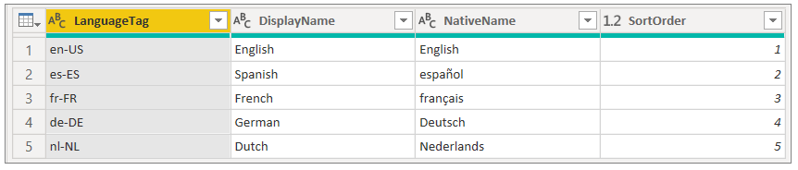

Next, let's examine the query named **ProductRows** query which creates a table with a single row for each product. The values in the **Product** column and the **Category** column are still in the default language which in this case is English.

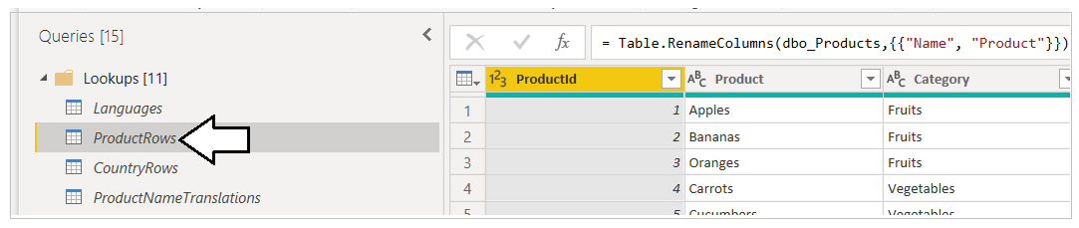

As you have seen, the **Languages** query generates a table which contains a row for each language and the **ProductRows** query generates a table with a row for each product. The problem to solve now is how to duplicate the output of the **ProductRows** query once for each language with translated content for the **Product** column and the **Category** column.

The **ProductSales.pbix** developer sample contains a query function named **GetProductTableTranslations** which accepts a single text parameter named **language** and returns a table with the rows of the **Products** table where the column values for **Property** and **Category** have been translated to a target language. The following code listing shows the M programming logic in the **GetProductTableTranslations** query function that accomplishes this task.

(language as text) =>

Let

// get rows from Products table

Source = ProductRows,

// add ProductTranslation column with translated product name

AddProductTranslation = Table.AddColumn(Source, "ProductTranslation",

each GetProductTranslation([Product], language)),

// add CategoryTranslation column with translated product name

AddCategoryTranslation = Table.AddColumn(AddProductTranslation, "CategoryTranslation",

each GetCategoryTranslation([Category], language)),

// remove Product column and Category column with orginal values

RemoveColumns = Table.RemoveColumns(AddCategoryTranslation,{"Product", "Category"}),

// Rename ProductTranslation and CategoryTranslation columsn to Product and Category

RenamedColumns = Table.RenameColumns(RemoveColumns,{{"ProductTranslation", "Product"},

{"CategoryTranslation", "Category"}}),

// set type of Product column and Categiry column to text

Output = Table.TransformColumnTypes(RenamedColumns,{{"Product", type text}, {"Category", type text}})

In

Output

If you want to test the **GetProductTableTranslations** query function in the Power Query Editor window, you can enter a value for the **language** parameter using one of the supported languages such as **fr-FR** and then click the **Invoke** button.

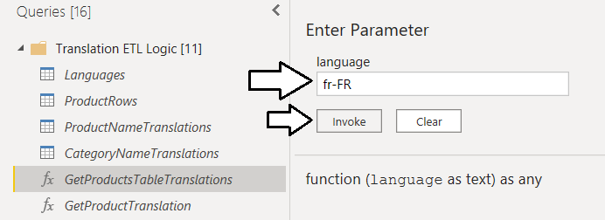

You can see that **GetProductTableTranslations** generates a new set of **Products** rows for a specific language.

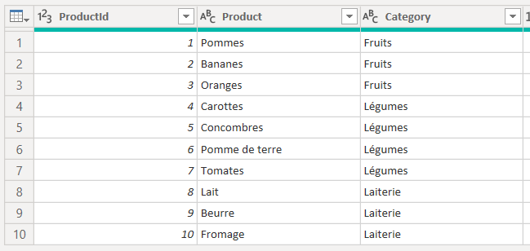

Let's now examine how product names and category names are translated for each language? The solution involves loading lookup tables that have the translations for each product name and product category. For example, there is a query named **ProductNameTranslations** which returns the data from a [product translation sheet](https://github.com/PowerBiDevCamp/Multilanguage-Reports/blob/main/Data/ProductSalesTranslations/ProductSales-Translations-ProductName.csv).

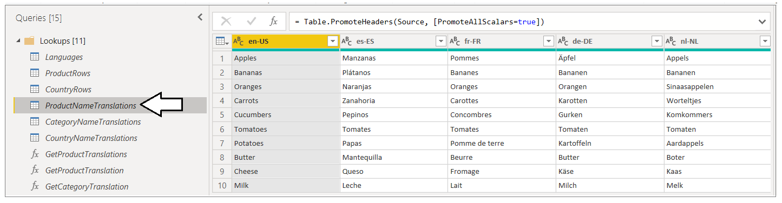

When the **GetProductTableTranslations** query runs, it calls two query functions named **GetProductTranslation** and **GetCategoryTranslation** to get the translations for each product name and category. The **GetProductTranslation** query function accepts two parameters named **product** and **language** and uses these parameters to locate the correct row and column in the lookup table from which it can extract and return the correct product name translation.

(product as text, langauge as text) =>

let

LookupTable = ProductNameTranslations,

LookupTableRow = Table.SelectRows(LookupTable, each [#"en-US"] = product),

LookupTableRowColumn = Table.SelectColumns(LookupTableRow, langauge),

Translation = Table.FirstValue(LookupTableRowColumn)

in

Translation

You have just reviewed the set of queries used to load the **Products** table with the row replication pattern to supply content translations for product names and product categories in five different languages. There are other queries in the project designed to load the **Countries** table with the row replication pattern to provide content translations for country names as well. The following screenshot shows the tables and fields in the data model that are loaded into memory.

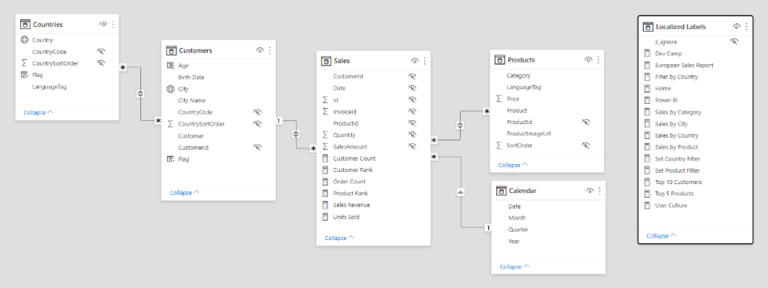

When you are implementing the row replication pattern, there is an issue concerning the relationships between fact tables and dimension tables. The issue is the **Products** table will now have more than one row with the same **ProductId** value. Since the **ProductId** column has duplicate values, you cannot use this column to create a one-to-many relationship between **Products** table and the **Sales** table. Instead you must create the relationship between these two tables as a many-to-many relationship.

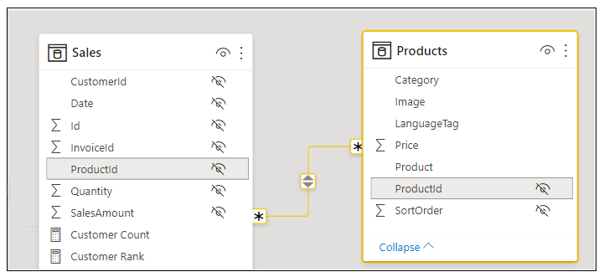

While Power BI supports many-to-many relationships between tables, they are not as efficient as one-to-many relationships. You might begin to experience performance problems as the number of rows in a dimension table with replicated rows increases. Performance will be fine as the number of product rows increase from 10 to 100 and even up to 1000. However, as the number of rows in the **Products** table rises above 1000 to reach 10,000 rows or more, it's likely that performance will begin to suffer and become unacceptable.

Now let's examine how this solution provides translated **Country** names. It would be possible to use the replicated row pattern on the **Customer** table. However, the **Customer** table is expected to have 100.000s of rows. This creates a performance problem because you'd have to create a many-to-many relationship between two tables where each tables contain a large number of rows.

Xxxxxx

Xxxxx

x

A better solution is to move from a star schema to a snowflake schema. You can accomplish this by factoring out country names from the **Customers** table into a separate **Countries** table. You should observe that this design makes it possible to maintain a one-to-many relationship between the **Customers** table and the **Sales** table which is essential for performance as both tables will have large row counts. While there is a many-to-many relationship between the **Countries** table and the **Customers** table, the number of rows in the **Countries** is small. Since there are six countries and five supported languages, there will only be 30 rows (6 countries * 5 languages) in the **Countries** table.

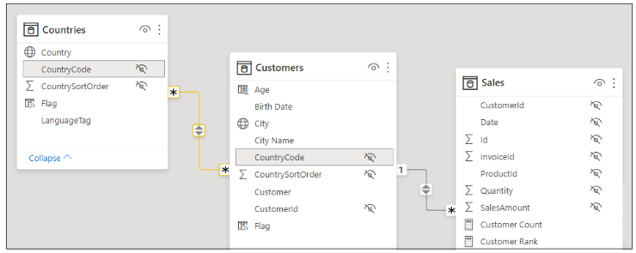

### Load Reports using Bookmarks to Filter Content Translations

Once you have created the queries to load tables which use the row replication pattern, you must then figure out how to filter table rows so a user only sees the rows for one language at a time. In the **ProductSales** developer sample, the two tables that require filtering are the **Products** table and the **Countries** table. The following screenshot show how you can set report-level filtering on the **LanguageTag** column of these two tables so only rows with **German** translations are displayed to the user.

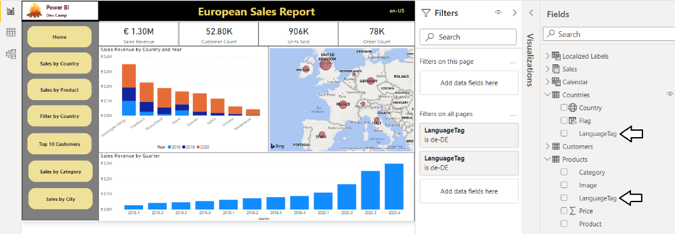

The best way to control filtering in a Power BI report is by creating a set of bookmarks. The **ProductSales.pbix** developer sample includes a set of bookmarks to apply the filtering required for each of the supported languages as shown in the following screenshot.

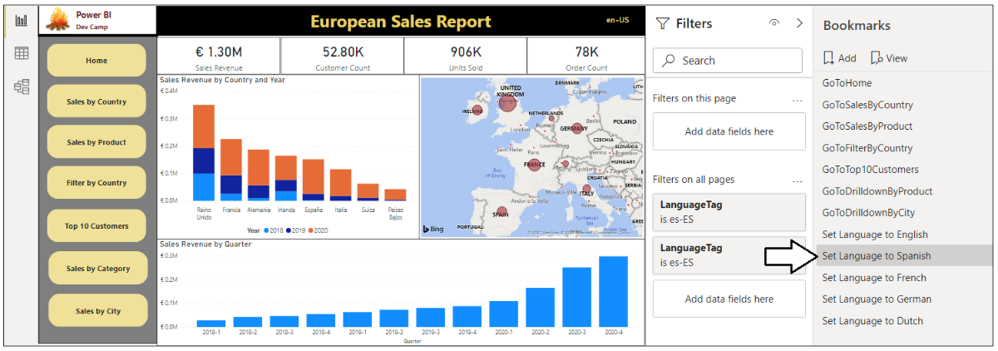

Earlier in this article, you learned that it is possible to open a report in the Power BI Service using the **language** query string parameter so it loads the metadata translations for a specific language. Now that the report implements content translations in addition to metadata translations, it necessary to pass a second query string parameter to apply a bookmark. This query string parameter is named **bookmarkGuid** which makes it possible to apply a bookmark as the report is loading before anything is displayed to the user.

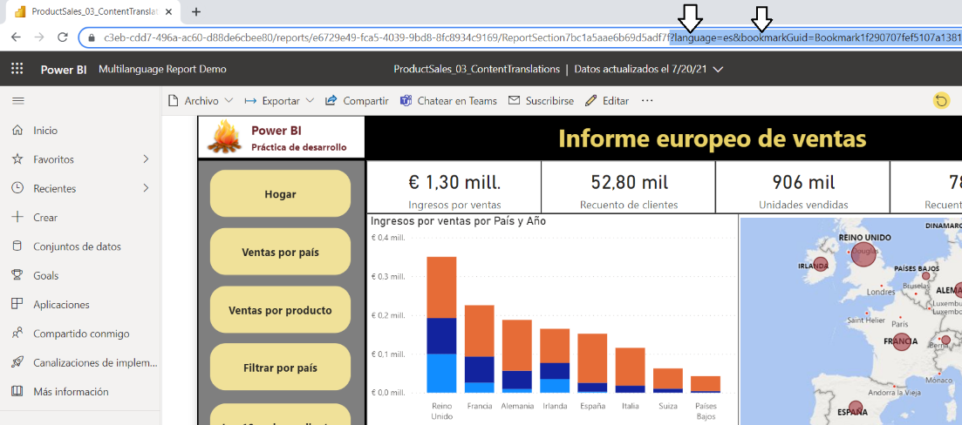

### Setting the Language for Current User using RLS and UserCulture

If you deploy a multi-language report through the Power BI Service, your deployment scenario might require you to use URLs with query string parameters for **language** and **bookmarkGuid** to ensure that reports load with the correct metadata translations and content translation filtering for a specific language. When you develop with Power BI embedding you have more control because you can embed the report with a **localeSettings** object which allows you to the specify the **language** and the **formatLocale**.

You can also control content translation filtering using Power BI features for Row Level Security (RLS). The approach involves creating a single RLS role named **LocalizedUser**. This RLS role applies a filter on the **Products** table where the **LanguageTag** column is equal to the return value of the **UserCulture** function.

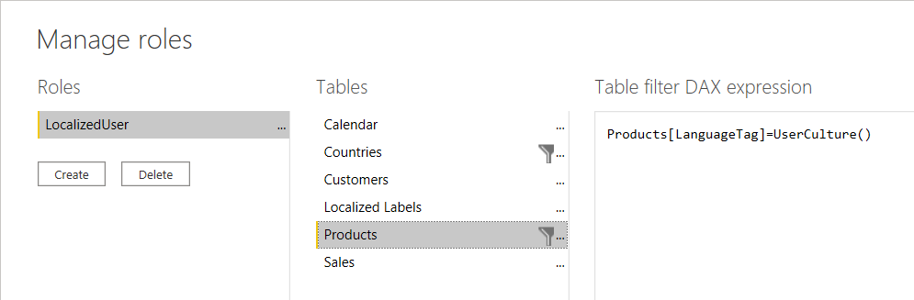

This RLS role applies a second filter on the **Countries** table where the **LanguageTag** column is equal to the return value of the **UserCulture** function.

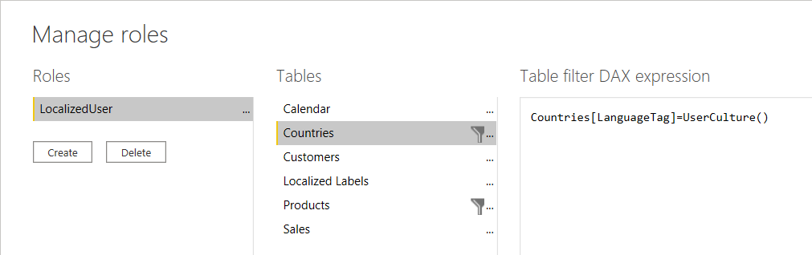

As you can see, the RLS roles has been designed to filter content translations based on the language and locale returned by the **UserCulture** function.

If you use this approach for implementing content translation while developing with App-Owns-Data embedding, you will be required to generate embed token with an effective identity which includes the RLS role named **LocalizedUser**. The following code listing demonstrates how to generate an embed token with an effective identity containing the **LocalizedUser** role using the Power BI .NET SDK.

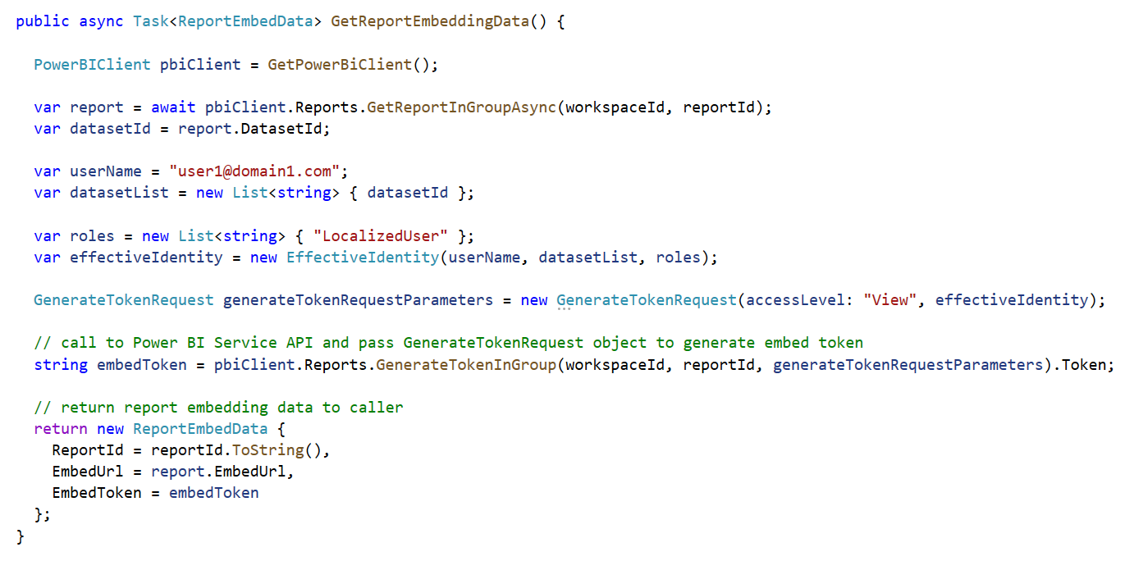

## Summary

TODO – complete summary